TYPES OF NUMBERS
- Natural numbers
They are numbers$\left(1,2,3,4,5,……..\right)$. They are also called positive integers, counting numbers or natural numbers.
- Whole numbers
This is a set of natural numbers, plus 0
$$\left\{0,1,2,3,4,5,6,…….\right\}$$
- Integers
This is a set of all whole numbers plus all the negatives of the natural numbers, i.e. $\left\{-2,-1,0,1,2,3,3,……\right\}$
- Fraction
Fractions are parts of whole numbers. These indicate that an integer is being divided by another integer. Examples $\frac{1}{2},\frac{3}{4}, \frac{5}{11}$ etc
- Decimals
Decimals are numbers based on the decimal system or the 10s system. Decimals use a dot or a point to separate the ones place from the tenths place in a number. There are one or more digits to the right-hand side of the dot or point called the decimal point.
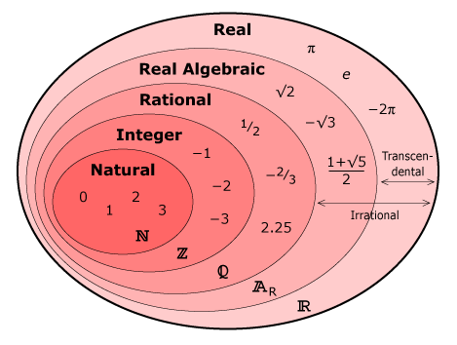
EVEN NUMBERS
Integers which are divisible by 2 are known as even numbers. In other words, numbers whose unit place is 0, 2, 4, 6, 8 are divisible by 2 and such numbers are even numbers.
OLD NUMBERS
Integers which are not divisible by 2 are known as odd numbers. They have 1, 3,5,7,9 at their unit place.
PRIME NUMBER
Prime numbers are those numbers which has only two factors ie. 1 and the number itself. For example:
- 2 is a prime number as its are 1 and 2.
- 7 is a prime number as its factors are 1 and 7.
A prime number is a number which can be divisible only by itself and the number 1.
What is the difference between prime and odd numbers?
- All the prime numbers are odd numbers but all the odd numbers are not prime numbers.
- A prime number is a number which can be divisible only by itself and the number 1.
Examples of prime numbers are 1, 2, 3, 5, 7, 11,13, 17 etc
- An odd number is a number which cannot be divided by the number 2. For example 2 is not odd as it is divisible by 2 but 7 is an odd number as it is not divisible by 2 and leaves remainder 1.
Examples of odd number are 1, 3, 5,7, 9,11 etc
Composite numbers
Composite numbers are those natural numbers which have more than two factors. Such numbers are divisible by other numbers as well.
For example 4,6,8,10,14,500,6000 etc
NUMBER LINE
A number line is a straight line with a zero point in the middle with positive and negative numbers listed on either side of zero and going on definitely.
RULES FOR INTEGERS
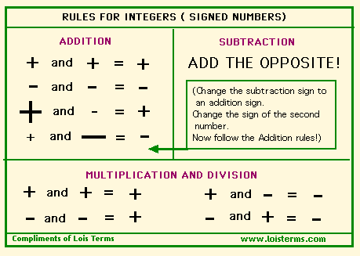
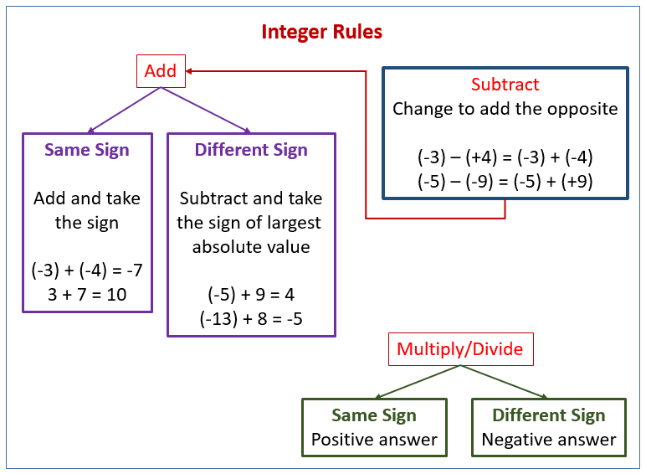
Rules on multiplication and division
- When you multiply two integers with different signs, the result is always negative. Just multiply the absolute values and make the answer negative.
- When you divide two integers with the same sign, the result is always positive. Just divide the absolute values and make the answer positive.
Rules on addition and subtraction
- To add integers having the same sign, keep the same sign and add the absolute value of each number.
- To add integers with different signs, keep the sign with the largest absolute value and subtract the smallest absolute value from the largest. Subtract and integers by adding its opposite.
EXAMPLES
  - What is 5$+ \left(-2\right)$?
$+\left(-\right)$ are Unlike signs (they are not the same), so they become a negative sign.
5$+ \left(-2\right)$ = 5$-$2 = 3
  - What is 25$- \left(-4\right)$?
$- \left(-\right)$ are like signs, so they become a positive sign.\
25$- \left(-4\right)$= 25$+ 4$ = 29
  - What is $-6+\left(+3\right)$?
$+\left(+\right)$ are like signs, so they become a positive sign.
$-6+\left(+3\right)$= -6+3 = -3
NUMBER LINE AND INTEGERS
Integers can be represented on the number line. On a number line, the positive numbers are to the right of zero and the negative numbers are to the left of zero.
RULES ON NUMBER LINE FOR ADDING AND SUBRACTING INTEGERS
- Add a positive integer by moving to the right on the number line.
- Add a negative inter by moving to the left on the number line.
- Subtract an integer by adding its opposite.
NUMBER LINE GRAPH
Graphing on a number line. Integers and real numbers can be represented on a number line. The point on this line associated with each number is called the graph of the number. Notice that number lines are spaced equally or proportionally.
INTERVALS
An interval consists of all the numbers that lie within two certain boundaries. If the two boundaries, or fixed numbers, are included, then the interval is a closed interval. If the fixed numbers are not included, then the interval is called an open interval.
If the interval includes only one of the boundaries, then it is called a half-open interval.
EXAMPLES OF USING BODMAS/ BEDMAS FOR ORDER OF
OPERATIONS
 | Do first
B racket
O rders of
D ivision
M ultplication
A ddition
S ubraction | Do last
BEDMAS
BEDMAS is an acronym to help remember an order of operations in algebra basics.
When you have math problems that require the use of different operations $\left(multiplicatons, divisions, exponents, brackets, subtraction, addition\right)$ order is necessary and mathematics have agreed on the BEDMAS order. Each letter of BEDMAS refers to one part of the operation to be used.
Each letter stands for
- B- Brackets
- E- Exponent
- D- Division
- M- Multiplication
- A- Addition
- S- Subtraction.
There are a couple of things to remember when applying the BEDMAS order of operations. Brackets always come first and exponents come second. When working with multiplication and division, you do which ever comes first as you work from left to right. If multiplication comes first, do it before dividing. The same holds true for addition and subtraction, when the subtraction comes first, subtract before you add.
It may help to look at BEDMAS like this:
- Brackets
- Exponents
- Division or Multiplication
- Addition or Subtraction
Example 1
20 - $\left[3x \left(2+4\right)\right]$ Do the inside bracket first
= 20 - $\left[3 x 6\right]$ Do the remaining bracket
= 20-18 Do the subtraction
=2
Example 2
${\left(6-3\right)}^{2}$ - 2 x 4 Do the bracket first
= ${\left(3\right)}^{2}$ - 2 x 4 Calculate the exponent
= 9- 2 x 4 Now multiply
= 9-8 Now subtract
= 1
Example 3
$2^{2}-3 \left(10-6\right)$Calculate inside the bracket
= $2^{2}-3 x 4$ Calculate the exponent
= 4- 3 x 4 Do the multiplication
=4-12 Do the subtraction
=-8
TYPES OF FRACTIONS
- Proper fraction
This is fraction where the numerator (top number) is smaller than Denominator(bottom number) e.g. $\frac{1}{3}$,$\frac{3}{8}$, $\frac{5}{13}$
- Improper fraction
The numerator is bigger than the denominator e.g. $\frac{11}{3}$,$\frac{23}{11}$, $\frac{15}{7}$
- Mixed numbers
It is a fraction which has the whole number and a fraction e.g.
4 $\frac{1}{3}$,$7\frac{3}{8}$, $15\frac{5}{13}$
NUMBERING SYSTEM
Explain four types of numbering system.
- The Decimal Numbering System
The decimal numbering system has values 0 to 9 (0, 1, 2,3,4,5,6,7,8 and 9). The numbers are to the base 10. These are numbers in everyday use.
- Octal Numbering System
These are numbers to base 8 as there 8 values used in the numbering system ( 0,1,2,3,4,5,6 and 7)
- Hexadecimal Numbering System
These are numbers to the base 16 and uses 16 symbols (0,1,2,3,4,5,6,7,8,9 A,B, C, D, E, F. The letters A, B, C , D , E are equivalent to 10,11,12,13,14 and 15 decimals)
- The Binary Numbering System
These are numbers to the base 2 and have values 0 to 1 (0 and 1 only).
Binary codes- refer to the binary notation used in computer system.

BINARY, OCTAL, DECIMAL AND HEXADECIMAL NUMBERS
Decimal | 0 | 1 | 2 | 3 | 4 | 5 | 6 | 7 | 8
Hex | 0 | 1 | 2 | 3 | 4 | 5 | 6 | 7 | 8
Octal | 0 | 1 | 2 | 3 | 4 | 5 | 6 | 7 | 10
Binary | 0 | 1 | 10 | 11 | 100 | 101 | 110 | 111 | 1000

Decimal | 9 | 10 | 11 | 12 | 13 | 14 | 15
Hex | 9 | A | B | C | D | E | F
Octal | 11 | 12 | 13 | 14 | 15 | 16 | 17
Binary | 1001 | 1010 | 1011 | 1100 | 1101 | 1110 | 1111
DECIMAL NUMBERS
Decimal number system uses 10 as a base and the numbers range from 0 to 9.
BINARY NUMBERS
Binary is a based 2 number system that has two symbols 1 and 0. Each successive digit represents a power of 2.
HOW TO CONVERT BINARY NUMBERS TO DECIMAL AND VICE VERSA
CONVERTING FROM DECIMAL NUMBERS TO BINARY NUMBER
EXAMPLES
Covert to the following binary numbers to decimal.
- ${10011}_{2}$
- ${1001}_{2}$
- ${1100}_{2}$
- ${10011}_{112}$
=${1 x 2}^{4}+0 x 2^{3 }+{0 x 2}^{2}+{1 x 2}^{1}+{1 x 2}^{0}$
= 16 + 0 + 0 + 2 + 1
= 19
- ${1001}_{112}$
=${1 x 2}^{3}+0 x 2^{2 }+{0 x 2}^{1}+{1 x 2}^{0}$
= 8 + 0 + 0 + 1
= 9
- ${1100}_{112}$
=${1 x 2}^{3}+1 x 2^{2 }+{0 x 2}^{1}+{0 x 2}^{0}$
= 8 + 4 + 0 + 1
= 13
Convert ${\left(36\right)}_{10}$ to binary
Divisor | Dividend | Quotient | Remainder
2 | 36 | 18 | 0
2 | 18 | 9 | 0
2 | 9 | 4 | 1
2 | 4 | 2 | 0
2 | 2 | 1 | 0
2 | 1 | 0 | 1
The binary equivalent of ${\left(36\right)}_{10}$ is ${\left(100100\right)}_{2}$
Convert ${\left(11010\right)}_{2}$ to decimal (base 10)
Binary Number | 1 | 1 | 0 | 1 | 0
 | $$2^{4}$$ | $$2^{3}$$ | $$2^{2}$$ | $$2^{1}$$ | $$2^{0}$$
 | 16 x 1 | 8 x 1 | 4 x 0 | 2 x 1 | 1 x 0
= 16 + 8 + 0 + 2 + 0
= 26
The decimal equivalent of ${\left(11010\right)}_{2}$ is ${\left(26\right)}_{10}$
OCTAL NUMBERS
These are numbers to base 8 as there 8 values used in the numbering system ( 0,1,2,3,4,5,6 and 7)
Conversion of Decimal to Binary
This involves the following steps
- Begin by dividing the decimal number by 8, the base of a octal number system.
- Note the remainder separately as the rightmost digit of the binary equivalent.
- Continually repeat the process of dividing by 8 until the quotient is zero and keep writing the remainders after each step of division.
- Finally, when no more division can occur, write down the remainders in reverse order (last remainder written first).
Example
Convert ${\left(359\right)}_{10}$ to octal
Divisor | Dividend | Quotient | Remainder
8 | 359 | 44 | 7
8 | 44 | 5 | 4
8 | 5 | 0 | 5
The octal equivalent of ${\left(359\right)}_{10}$ is ${\left(547\right)}_{8}$
Convert ${1456}_{10}$ to base 8
Divisor | dividend | Quotient | Remainder
8 | 1456 | 182 | 0
8 | 182 | 22 | 6
8 | 22 | 2 | 6
8 | 2 | 0 | 2
Now we write the remainder upwards, that is ${1456}_{10}$ is${2660}_{8}$
- ${11}_{10}$ to base 8
Divisor | Dividend | Quotient | Remainder
8 | 11 | 1 | 3
8 | 1 | 0 | 1
Now we write the remainder upwards, that is ${11}_{10}$ is${13}_{8}$
- ${64}_{10}$
Divisor | Dividend | Quotient | Remainder
8 | 64 | 8 | 0
8 | 8 | 1 | 0
8 | 1 | 0 | 1
Now we write the remainder upwards, that is ${64}_{10}$ is${100}_{8}$
CONVERSION OF OCTAL TO DECIMAL
In the octal to decimal conversion, each digit of the octal number is multiplied by its weighted position, and each of the weighted values is added together to get the decimal number.
Example
Convert ${\left(456\right)}_{8}$ to decimal
Binary Number | 4 | 5 | 6
 | $$8^{2}$$ | $$8^{1}$$ | $$8^{0}$$
 | 64 x 4 | 8 x 5 | 1 x 6
 | 256 | 40 | 6
Sum of the weight of all bits = 256 + 40 + 6
= 302
The decimal equivalent of ${\left(456\right)}_{8}$ is ${\left(302\right)}_{10}$
SOLUTIONS
CONVERT OCTAL NUMBERS TO DENARY NUMBERS
- Convert ${100}_{8}$ to base 10
Octal number | 1 | 0 | 0
 | $$8^{2}$$ | $$8^{1}$$ | $$8^{0}$$
 | 1x $8^{2}$ =64 | 0x $8^{2}$ =0 | 0x $8^{2}$ = 0
Denary number | 64 + 0 + 0 = ${64}_{8}$
- Convert ${5406}_{8}$ to base 10
Octal number | 5 | 4 | 0 | 6
 | $$8^{3}$$ | $$8^{2}$$ | $$8^{1}$$ | $$8^{0}$$
 | 1x $8^{2}$ =64 | 0x $8^{2}$ =0 | 0x $8^{2}$ = 0
Denary number | 64 + 0 + 0 = ${64}_{8}$
Exercise
- Convert ${\left(010111\right)}_{2}$ to octal
- The binary equivalent of ${\left(231\right)}_{8}$
- Convert${\left(231\right)}_{8}$ to binary
HEXADECIMAL NUMBERS
These are numbers to the base 16 and uses 16 symbols (0,1,2,3,4,5,6,7,8,9 A,B, C, D, E, F. The letters A, B, C , D , E are equivalent to 10,11,12,13,14 and 15 decimals)
CONVERSION FROM DECIMAL TO HEXADECIMAL
To convert a decimal number into its hexadecimal equivalent, the same procedure is adopted as decimal to binary conversion but the decimal number is divided by 16 ( the base of the hexadecimal number system)
Example
Convert ${\left(5112\right)}_{10}$ to hexadecimal
Divisor | Dividend | Quotient | Remainder
16 | 5112 | 319 | 8
16 | 319 | 19 | F
16 | 19 | 1 | 3
16 | 1 | 0 | 1
The hexadecimal equivalent of ${\left(5112\right)}_{10}$ is ${\left(13F8\right)}_{16}$
CONVERSION OF HEXADECIMAL TO DECIMAL
Convert ${\left(B14\right)}_{16}$ to decimal
Binary Number | B=11 | 1 | 4
Weight of each bit | $${16}^{2}$$ | $${16}^{1}$$ | $${16}^{0}$$
Weighted value | 256 x 11 | 16 x 1 | 1 x 4
Solved multiplication | 2816 | 16 | 4
Sum of the weight of all bits = 2816 + 16 + 4
= 2836
The decimal equivalent of ${\left(B14\right)}_{16}$ is ${\left(2836\right)}_{10}$
Convert ${\left(11001011\right)}_{2}$ to hexadecimal.
Binary Number | 1100 | 1011
Decimal Number | 12 | 11
Hex Number | C | B
The hex equivalent of ${\left(11001011\right)}_{2}$ = ${\left(CB\right)}_{16}$
Conversion of Hexadecimal to Binary
This involves converting each hexadecimal digit to its 4-bit binary equivalent and combining the 4-bit sections by removing the spaces to get the binary number.
BINARY ARITHMETIC
ADDITION OF BINARY NUMBERS
In binary addition, 1 plus 1 = 10 and 10 plus 10 = 100.
INPUT |  | OUTPU
X | Y | SUM(S) | CARRY(C)
0 | 0 | 0 | 0
0 | 1 | 1 | 0
1 | 0 | 1 | 0
1 | 1 | 0 | 1
SUBTRACTION OF BINARY NUMBERS
INPUT |  | OUTPUT
X | Y | SUM(S) | CARRY(C)
0 | 0 | 0 | 0
0 | 1 | 1 | 1
1 | 0 | 1 | 0
1 | 1 | 0 | 0
The following steps are involved
- First, for the least significant bit (the right most), 1-1 is 0.
- For next bit, 0-1 cannot be computed since the subtrahend is smaller than the minuend. The operation is 10-1=1 which in the decimal number system is 2-1 =1.
- For the third bit, since we borrowed 1 for the second bit, we have 0-0 that is 0.
- For the fourth bit again, we cannot perform the subtraction. However, the fifth bit in the minuend is zero, so we must borrow from the sixth bit. This makes bit 10. Now the subtraction in binary is 10-1 =1 which is the result of the fourth bit.
- Since we borrowed 1 from the sixth bit for the fourth bit, so for the sixth bit, the subtraction is 0-0=0.
OCTAL ADDITION
During the process of addition, if the sum is less than or equal to 7, then it can be directly written as an octal digit.If the sum is greater than 7, then subtract 8 from that particular digit and carry 1 to the next digit position
Add the octal numbers 5647 and 1425.
5 6 4 7
+ 1 4 2 5
7 10 7 12
8 -8
7 2 7 4
OCTAL SUBTRACTION
During octal subtraction, instead of 1, we will borrow 8 and 8 and the rest of the steps are similar to that of binary subtraction.
Example
Subtract ${677}_{8} from {770}_{8}$
7 7 0
- 6 7 7
0 7 1
Thus the difference is ${71}_{8}$
HEXADECIMAL ADDITION
During the process of addition, observe if the sum is 15 or less, then it can be directly expressed as a hexadecimal digit.
If the sum is greater than 15, then subtract 16 from that particular digit and carry 1 to the next digit position.
Example
Add the hex numbers ${76}_{16}$ and ${45}_{16}$
7 6
+ 4 5
11 11
B B
PERFORMING SUBRACTIONS AND ADDTION IN DIFFERENCES BASES
Examples
- Subtract ${1264}_{b}$from ${30155}_{6}$ leave your to base 10.
Changing the given number to base ten
${1264}_{8}$= ${1 x 8}^{3} +{2 x 8}^{2}+{6 x 8}^{1}+{4 x 8}^{0}$
= 1 x 512 + 2 x 64 + 6 x 8 + 4 x 1
=512 + 128 +48 + 4
=${692}_{10}$
${30155}_{5}$= ${3 x 6}^{4} +{0 x 6}^{3}+{1 x 6}^{2}+{5 x 6}^{1}+{5 x 6}^{o}$
= 3 x 1296 + 0 x 216 + 1 x 36 + 5 x6 + 5 x 1
= 3888+ 0+ 36 + 30 + 5
=${3959}_{10}$
Then subtract ${692}_{10}$ from ${3959}_{10}$
 | 3 | 9 | 5 | 9
- |  | 6 | 9 | 2
 | 3 | 2 | 6 | 7
$$∴{3267}_{10}$$
- Evaluate ${3452}_{6}$ $+$ ${7634}_{8}$, convert your answer to base 5.
Changing the given number to base ten
${3452}_{8}$= ${3 x 6}^{3} +{4 x 6}^{2}+{5 x 6}^{1}+{2 x 6}^{0}$
= 3 x 216 + 4 x 36 + 5 x 6 + 2 x 1
=648 + 144 +30 + 2
=${824}_{10}$
${7834}_{8}$= ${7 x 8}^{3} +{8 x 8}^{2}+{3 x 8}^{1}+{4 x 8}^{0}$
= 7 x 512 + 8 x 64 + 3 x 8 + 4 x1
= 3584+ 512 + 24 + 4
=${4124}_{10}$
Then add ${3452}_{6}$ to ${7634}_{8}$
 |  | 8 | 2 | 4
+ | 4 | 1 | 2 | 4
 | 4 | 9 | 4 | 8
$Convert {4948}_{10}$ to base 5

Divisor | Dividend | Quotient | Remainder
5 | 4948 | 989 | 3
5 | 989 | 197 | 4
5 | 197 | 39 | 2
5 | 39 | 7 | 4
5 | 7 | 1 | 2
5 | 1 | 0 | 1
$$∴{124243}_{5}$$
What is ${1111}_{2}$ in decimal (base10)?
- The “1” on the left is in the “2x2x2” position , so that means 1 x 2 x 2 x2 (= 8)
- The next “1” is in the “ 1x 2 x2 (=4) position so that means 1 x 2 x 2 (=4).
- The next “1” is in the “ 2” position so that means 1 x 2(=2).
- The last “1” is in the “1”position so that means 1
1 x $2^{3}$ $+$ $2^{2}$ $+$ $2^{1}$ $+2^{0}$ = 8 + 4 +2 +1
= ${15}_{2}$
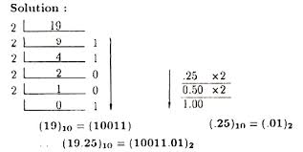

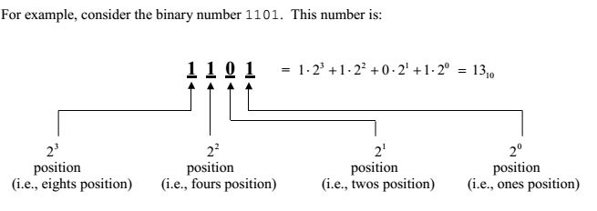
Convert ${A37E}_{16}$ to base 10.
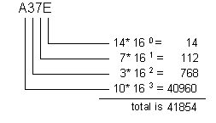
Convert ${10011011}_{2}$n to base 10.
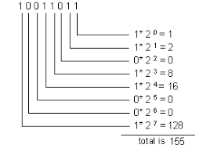
Convert ${47}_{10}$to binary
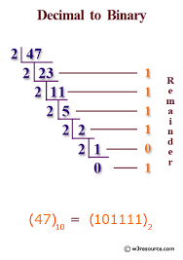
Convert ${11011011}_{2}$ base 10.
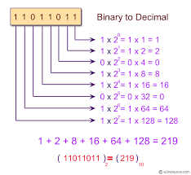
SET THEORY
A set is a collection of objects called members or elements that is regarded as being a single object.
SUBSET
A is a subset of B if and only if every element of A is in B.
A is a subset of B if and only if every element of A is in B.
Example
Is A a subset of B, where A = $\left\{1,3,4\right\}$ and B =$\left\{1,4,3,2\right\}$?
1 is in A, and 1 is in B as well, so far so good.
3 is in A and 3 is also in B
4 is in A and 4 is in B.
That’s all the elements of A , and every single one is in B , so we are done.
Yes , A is a subset of B
EMPTY (or NULL/VOID) SET
It is a set which does not contain any elements. There isn’t any element. Not one. Zero. It is represented by $∅$ or by $\left\{\right\}\left(a set with no elements\right)$
FINITE SET
It is a set which contains a definite number of elements. Empty set is also called a finite set.
Example
- The set of all colours in the rainbow
- N = $\left\{x :x∈n, x <7\right\}$, This mean N= $\left\{1,2,3,4,5,6\right\}$
- P = $\left\{2,3,5,7,11,13,17,…..97\right\}$
INFINITE SET
It is a set whose elements cannot be listed, i.e., set containing never-ending elements.
Examples
- A = $\left\{x :x ∈N , x >1\right\}$
- Set of all prime numbers
CARDINAL NUMBER OF A SET
It is the number of distinct elements in a given set A. It is denoted by n$\left(A\right)$.
Examples
- A = $\left\{x :x∈n, x <7\right\}$. Find n$\left(A\right)$
A =$\left\{1,2,3,4,5,6\right\}$. Therefore n$\left(A\right)$ = 6
- B = set of letters in the word Algebra
B = $\left\{A,L,G,E,B, R,A\right\}$, Therefore n$\left(B\right)$ = 7
EQUIVALENT SETS
Two sets A and B are said to be equivalent if their cardinal number is the same i.e n$\left(A\right)$ = n$\left(B\right)$. The symbol for denoting an equivalent set is ‘$↔$’.
Example
A = $\left\{1,2,3\right\}$. Here n$\left(A\right)$ = 3
B = $\left\{p,q,r\right\}$ Here n$\left(B\right)$ = 3
There , A $↔B$
EQUAL SETS
Two sets are equal if they have precisely the same members.
Example
Are A and B equal where A is the set whose members are the first four positive whole numbers, B =$\left\{4,2,1 3\right\}$.
Let’s check. They both contain 1. They both contain 2, And 3, And 4. And we have checked every element of both sets, so Yes, they are equal.
Therefore A = B
Are these sets equal?
A is$\left\{1,2 3\right\}$.
B is$\left\{3,1,2\right\}$.
Yes, they are equal. They both contain exactly the members 1, 2 and 3. It doesn’t matter where each member appears, so long as it is there.
INTERSECTION OF SETS
Intersection of two given sets is the largest set which contains all the elements that are common to both the sets. To find the intersection of two given sets A and B is a set which consists of all the elements which are common to both A and B. The symbol for denoting intersection is ‘$∩$’.
EXAMPLES
- If A = $\left\{2,4,6,8,10\right\}$ and B =$\left\{1,3,8,4,6\right\}$. Find intersection of two set A and B.
A$∩$B =$\left\{4,6,8\right\}$.
Therefore, 4, 6 and 8 are the common elements in both the sets.

- If Set A =$\left\{4,6,8,10,12\right\}$, set B $=\left\{3,6,9,12,15,18\right\}$ and Set C= $\left\{1,2,3,4,5,6,7,8,9,10\right\}$.
- Find the intersection of sets A and B.
- Find the intersection of two set B and C.
- Find the intersection of the given sets A and C.
- The set of all the elements which are common to both set A and B is A$∩$B = $\left\{6,12\right\}$
- Set of all the elements which are common to both set B and set C is B$∩$C = $\left\{3,6,9\right\}$
- Intersection of the given sets A and C is A$∩$C = $\left\{4,6,8,10\right\}$
Set of all the elements which are common to both set A and set C.
UNION OF SETS
Union of two given sets is the smallest set which contains all the elements of both the sets.
For two sets A and B, n$\left(A\bigcup{B}\right)$ is the number of elements present in either of the sets A or B. To find the union of two given sets A and B is a set which consists of all elements of A and all the elements of B such that no element is repeated. The symbol for denoting union of sets is $∪$.
EXAMPLES
- Given A = $\left\{2,4,5,6\right\}$ and set B =$\left\{4,6,7,8\right\}$. Find A$∪B$.
Taking every element of both the sets A and B, without repeating any element, we get a new set, A$∪B$=$\left\{2,4,5,6,7,8\right\}$. This new set contains all the elements of set A and all the elements of set B with no repetition of elements and is named as union of set A and B.
- If A = $\left\{1,3,7,5 \right\}$ and B =$\left\{3,7,8,9\right\}$. Find union of set A and B.
A$∪$B=$\left\{1,3,5,7,8,9\right\}$. No element is repeated in the union of two sets. The common elements 3, 7 are taken only once.
- Let X = $\left\{a,e,i,o,u\right\}$ and Y = $\left\{∅\right\}$. Find the union of two given sets X and Y.
X$∪$Y =$\left\{a,e,i,o,u\right\}$. Therefore, union of any set with empty set is the set itself.
- If set P =$\left\{2,3,4,5,6,7\right\}$, set Q =$\left\{0,3,6,9,12\right\}$ and set R = $\left\{2,4,6,8\right\}$.
- Find the union of sets P and Q.
- Find the union of two set P and R.
- Find the union of the given sets Q and R.
Solution:
- Union of sets P and Q is P$∪$Q
The smallest set which contains the elements of set P and all the elements of set Q is P$∪$Q$\left\{0,2,3,4,5,6,7,9,12\right\}$
- Union of two set P and R is P$∪$Q
The smallest set which contains all the elements of set P and all the elements of set R is P$∪$Q = $\left\{2,3,4,5,6,7,8\right\}$
- Union of the given sets Q and R is Q$∪$R
- The smallest set which contains all the elements of set Q and all the elements of set R is Q$∪$R = $\left\{0,2,3,4,6,8,9,12\right\}$
INTERESECTION OF SETS
n$\left(A\bigcap{B}\right)$ is the number of elements present in both the sets A and B .
n$\left(A\bigcup{B}\right)$ = $n\left(A\right)$ + $\left(B\right)$B - n$\left(A\bigcap{B}\right)$
For three sets A, B and C:
n$\left(A\bigcup{B\bigcup{C}}\right)$ = $n\left(A\right)$ + $\left(B\right)$ + $\left(\bigcap{C}\right)$ - $\left(A\bigcap{B}\right)- \left(B\bigcap{C}\right)-\left(C\bigcap{A}\right)+$n$\left(A\bigcap{B\bigcap{C}}\right)$
Examples
Let A and B be two finite sets such that n(A) - 20, n(B)= 28 and n(A$\bigcup{B}$) =36, find n($\bigcap{B)}$.
Using the formula n (A$\bigcup{B}$) = n (A) + (B) - n ($\bigcap{B)}$.
= 20+28-36
= 48-36
= 12
If (A- B) = 18, n (A$\bigcup{B}$) =70 and ($\bigcap{B)}$=25, then find n (B).
Using the formula n($∪)$= n$\left(A-B\right)$ + n$\left(A∩B\right)$ + n$\left(B-A\right)$
70 = 18 +25 + n$\left(B-A\right)$
70 - 41 =
70 = 43 +(A-B)
n(B-A) =70-43
n(B-A) =27
Now n(B) = n(A$∩B$) +(B-A)
=25 +27
=52
In a group of 60 people, 27 like cold drinks and 42 like hot drinks and each person like at least one of the drinks. How many like both cold drinks and hot drinks?
Let A= set of people who like cold drinks
B =set of people who like hot drinks
(A$∪$B) =60, n(A) = 27, n(B) = 42 then
(A$∪$B) = n(A) + n(B) $-$n$\left(A∩B\right)$
60 = 27 + 42 $-$n$\left(A∩B\right)$
60 =69$-$n$\left(A∩B\right)$
60-69 = $-$n$\left(A∩B\right)$
-9 = $-$n$\left(A∩B\right)$
n$\left(A∩B\right)$ =9
There are 35 students in art class and 57 students in dance class.
  - Find the number of students who are either in art class or in dance class when two classes meet at the same hour.
n (A$\bigcup{B}$) = n (A) + (B) - n ($\bigcap{B)}$.
= 35 +57 - $∅$
= 92
  - Find the number of students who are either in art class or in dance class when two classes meet at different hours and 12 students are enrolled in both activities.
n (A$\bigcup{B}$) = n (A) + (B) - n ($\bigcap{B)}$.
= 35 +57 -12
= 92-12
= 80
In a class of 100 students, 35 like science and 45 like math. 10 like both. The information is represented in the Venn diagram. How many like either of them and how many like neither.
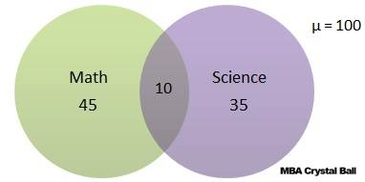
n$\left(S\bigcup{M}\right)$ = $n\left(S\right)$ + $\left(M\right)$B - n$\left(S\bigcap{M}\right)$
= 45 + 35 -10
= 70
Among a group of students, 50 played cricket, 50 played hockey and 40 played volley. 15 played both cricket and hockey, 20 played both hockey and volley ball, 15 played cricket and volley ball and 10 played all three. If every student played at least one game, find the number of students and how many played only cricket, only hockey and only volley?
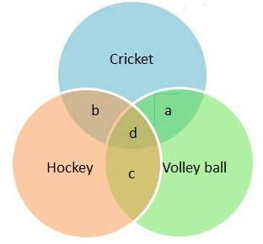
n$\left(C\right)=50$,$n\left(H\right)=50$, $n\left(V\right)=40$
$n\left(C\bigcap{H}\right)$=15, $n\left(H\bigcap{V}\right)=20, n\left(C\bigcap{V}\right)=15$, $n\left(C\bigcap{H\bigcap{V}}\right)=10$
Now
$n\left(C\bigcap{H}\right)=b+d=15$,
$n\left(H\bigcap{V}\right)=c+d=20$,
$n\left(C\bigcap{V}\right)=a+15$,
$n\left(C\bigcap{H\bigcap{V}}\right)=10=d$,
Therefore, a= 15-10 = $5\left[cricket and volley ballonly\right]$
b= 15-10 = 5 $\left[cricket and hockey only\right]$
c= 20-10 =10 $\left[hockey and volley ball only\right]$
Number of students who played only hockey =n$\left(H\right)-\left[b+c+d\right]$
= 50 - $\left[5+10+10\right]$
= 25
Number of students who played only volley ball =n$\left(V\right)-\left[a+c+d\right]$
= 40 - $\left[10+5+10\right]$
= 15
Number of students who played only cricket =n$\left(C\right)-\left[a+b+d\right]$
= 50 - $\left[5+10+10\right]$
= 25
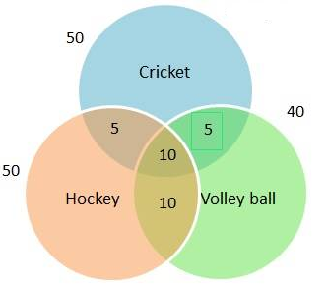
COMPLEMENT OF SETS
In set theory, the complement of a set A refers to the elements not in A. When all sets under consideration are considered to be subsets of a given set $∪$ =, the absolute complement of a is the set of elements in $∪$ but not in A.
The complement of set A, denoted by$A^{'}$, is the set of all elements in the universal set that are not in A. It is denoted by $A^{'}$.
EXAMPLES
If A = $\left\{1,2,3,4\right\}$ and $∪$ = $\left\{1,2,3,4,5,6,7,8\right\}$, find A complement $\left(A^{'}\right)$.
Complement of set A contains elements present in universal set but not in se A.
Elements are 5,6,7,8
$∴$A complement, $A^{'}$ = $\left\{5,6,7,8\right\}$
EXERCISE
- There are 30 students in a class. Among them, 8 students are learning both English and French. A total of 18 students are learning English. If every student is learning at least one language, how many students are learning French in total?
- In a class of 100 students, 35 like science and 45 like math. 10 like both. How many like neither. Use the Venn diagram below to find the answer.
- There are 30 students in a class. Among them, 8 students are learning both English and French. A total of 18 students are learning English. If every student is learning one language, how many students are learning French in total. Use the Venn diagram below that illustrates the information to
- Use Venn diagram: In a school, there are 20 teachers who teach Mathematics or English. Of these, 12 teach Mathematics and 4 teach both English and Mathematics . How many teach English only.
MULTIPLICATION AND DIVISION OF ALGEBRAIC EXPRESSION
MULTIPLYING ALGEBRAIC EXPRESSIONS
We can multiply two algebraic terms to get a product, which is also an algebraic term.
Example
- Evaluate 3p$q^{3}$ x 4qr
Solution
3p$q^{3}$ x 4qr = 3 x p x q x q xq x 4 x q x r
= 3 x 4 x p x q xq xq x q xr
= 12 x p x $q^{4}$r
= 12p$q^{4}$r
LIKE TERMS AND UNLIKE TERMS
In algebra, terms that have the same letter or letters are called like terms. They must have the same letters in any order but they may have different numerical coefficients.
The process of adding or subtracting like terms is called collecting like terms.
EXAMPLES
Simplify the following algebraic expression
- 5p$x^{2}$-qz -3p$x^{2}$ +4qz = 5p$x^{2}$--3p$x^{2}$+4qz -qz
= 2p$x^{2}$+3qz
- 8x-2y+5x+10y = 8x+5x+10y-2y
= 13x+ 8y
- 4ab-2bc-3ab +3cd = 4ab-3ab+3cd-2bc
= ab-2bc+3cd
- 9xy+5x-4xy-2x = 9xy-4xy+5x-2x
= 5xy +3x
ALGEBRA EXPANSION
Expanding means removing the but we have to do it the right way are called ‘parentheses” or “brackets”. Whatever is inside the needs to be treated as “package”. So when simplifying: multiply by everything inside the “package”.
EXAMPLES
Expand the following
- $5\left(y+3\right)$ = 5y + 15
- $a\left(y+3\right)$ = ay + 3a
- $-3\left(y+3\right)$ = $-$3y$-$9
- $-b\left(x-y\right)$ = $-bx+by$
EXERCISE
- Expand the following brackets

- $5\left(y+3\right)$
- $9\left(x-1\right)$
- $4\left(a+2\right)$
- $8\left(w+10\right)$
- $3\left(x-7\right)$
- $2\left(8-t\right)$
- $3\left(7a+2\right)$
- $4\left(3y+2\right)$
- $7\left(9-2c\right)$
- $11\left(2k-5\right)$
- $3\left(15w-7\right)$
- $20\left(6a+5c\right)$
- $3\left(9-2a\right)$
- $9\left(2x-5\right)$
- $5\left(2p-1\right)$
- $4\left(3y+2\right)$
- $9\left(2x-5\right)$

- Expand the following brackets

- $a\left(y-3\right)$
- $c\left(x-1\right)$
- $b\left(a+2\right)$
- $2a\left(w+10\right)$
- $3p\left(x+7\right)$
- $2t\left(8-t\right)$
- $p\left(7a+2\right)$
- $y\left(3y+2\right)$
- $2a\left(9-2c\right)$
- $3r\left(2k+5\right)$
- $3y\left(15w+7\right)$
- $2v\left(6a+5c\right)$
- $m\left(9n-2a\right)$
- $3x\left(2x+5\right)$
- $5g\left(2p+4y\right)$
- $t\left(3y+2\right)$
- $w\left(2x+6\right)$

- Expand the following brackets

- $-5\left(y+3\right)$
- $-9\left(x-2\right)$
- $-4\left(a-2\right)$
- $-8\left(w+2\right)$
- $-3\left(x+7\right)$
- $-2\left(8-t\right)$
- -$3\left(7a+2\right)$
- $-4\left(3y-2\right)$
- $-7\left(9+2c\right)$
- $-2\left(2k-5\right)$
- $-3\left(15w+7\right)$
- $-2\left(6a+5c\right)$
- $-5\left(2p-1\right)$
- $-4\left(3y+2\right)$
- $-9\left(2x-5\right)$

Expand the following algebraic expressions
- $\left(2x+3\right)\left(x-1\right)$ =2$x^{2}-2x+3x-3$
= 2$x^{2}+x-3$
- $\left(x+3\right)\left(x+2\right)$= x$\left(x+2\right)+$3$\left(x+2\right)$
= $x^{2}+2x$ $+3x+6$
= $x^{2}+5x+6$
- $\left(3x+2\right)\left(x+3\right)$=$3x\left(x+3\right)$+2$\left(x+3\right)$
= 3$x^{2}+9x+2x+6$
RULES OF ALGEBRA EXPANSION
- $\left(a+b\right)\left(a-b\right)$ =$a^{2}-b^{2}$
- ${\left(a+b\right)}^{2}$= $a^{2}$ $+2ab+b^{2}$
- ${\left(a-b\right)}^{2}$ = $a^{2}-2ab+b^{2}$
Expand the following

- $\left(x-3\right)\left(x-4\right)$
- $\left(x+5\right)\left(x-4\right)$
- $\left(2x+1\right)\left(3x-2\right)$
- $\left(3y-3\right)\left(2y+2\right)$
- $\left(x-1\right)\left(x+1\right)$
- $\left(x-4\right)\left(x+4\right)$
- $\left(y-2\right)\left(y+2\right)$
- $\left(x-4\right)\left(x-4\right)$
- $\left(x+4\right)\left(x+3\right)$

CO-ORDINATE GEOMETRY
GRADIENT AND EQUATION OF A STRAIGHT LINE IN THE FORM OF Y = MX +C
Gradient is a measure of how sloppy line on a plane is with respect to the horizontal.
In Cartesian plane, a gradient of a line is defined as the change in y-value divided by the change in x-value.
Gradient = $\frac{Change in y-values}{Change in x-value}$
Find the gradient of the straight line joining P ($x_{1},y_{1}$) and$Q\left(x_{2},y_{2}\right)$.
Gradient = $\frac{y_{2}-y_{1}}{x_{2}-x_{1}}$
Examples
Find the gradient of the line segment joining the following points
- A= $\left(1,1\right)$ and B =$\left(5,2\right)$
Gradient = $\frac{y_{2}-y_{1}}{x_{2}-x_{1}}$
Gradient = $\frac{2-1}{5-1}$
= $\frac{1}{4}$

- P=$\left(-2,3\right)$ and Q = $\left(-2,1\right)$
Gradient = $\frac{y_{2}-y_{1}}{x_{2}-x_{1}}$
Gradient = $\frac{1-3}{-2--2}$
= $\frac{2}{0}$
= Undefined (We cannot divide by zero)
EXERCISE
Find the gradient and the equation of the line joining the following points.
- A= $\left(4,3\right)$ and B =$\left(7,5\right)$
- P=$\left(8,1\right)$ and Q = $\left(4,2\right)$
- M= $\left(0,-5\right)$ and N = $\left(-1,-3\right)$
- X= $\left(-2,3\right)$ and Y = $\left(-3,1\right)$
- B= $\left(-2,3\right)$ and C = $\left(-3,1\right)$
GRADIENT AND Y-INTERCEPT
Given the straight lines whose equation is:
- y = $\frac{2}{5}$x $-$3
Y = mx + c where m = gradient and c = y-intercept
Gradient = $\frac{2}{5}$
Y- intercept = -3
- 2x + 3y = 7.
First make y the subject of the formula where Y = mx + c where m = gradient and c = y-intercept
3y = 7 $-$2x
y = $\frac{7}{3}$ $-\frac{2}{3}x$
$∴$Gradient = $\frac{-2}{3}$
$∴$Y-intercept = $\frac{7}{3}$
EQUATION OF A LINE FROM ORDERED PAIRS (X, Y)
Example
Find the gradient and the equation of the line joining points A= $\left(-1,3\right)$ and B =$\left(3,5\right)$.
Equation of the straight line takes the form of Y = mx + c where m = gradient and c = y-intercept
Gradient, m = $\frac{y_{2}-y_{1}}{x_{2}-x_{1}}$
Gradient, m = $\frac{5-3}{3--1}$
= $\frac{2}{4}$
= $\frac{1}{2}$
To find c, Y = $\frac{1}{2}x+c$ passes through the point B(3,5)
5 = $\frac{1}{2}\left(3\right)+c$
5 =$\frac{3}{2}$ + c
- $-1.5=c$
  - = c
Equation of the straight line, Y = $\frac{1}{2}x+3.5$
EXERCISE
Find the gradient and the equation of the line joining the following points.
- A= $\left(-1,3\right)$ and B =$\left(3,5\right)$
- P=$\left(1,1\right)$ and Q = $\left(2,4\right)$
- M= $\left(2,6\right)$ and N = $\left(3,8\right)$
- X= $\left(2,6\right)$ and Y = $\left(3,8\right)$
- B= $\left(-3,2\right)$ and C = $\left(-1,3\right)$
GEOMETRY- TYPES OF ANGLES
- Acute angle- This is angle that is less than ${90}^{0}$. In other words, an acute angle is an angle measuring between 0 and 90 degrees.
- Right angle- A right is an angle measuring 90 degrees. Two lines or lines segments that meet at a right angle are said to be perpendicular.
- Obtuse angle- An obtuse angle is an angle measuring between 90 and 180 degrees.
- Straight angle - A straight angle is a straight line and it measures 180 degrees.
- Reflex angle- A reflex angle is an angle measuring between 180 and 360 degrees.
- Full rotation or angle at a point- Angles at a point add up to 360 degrees
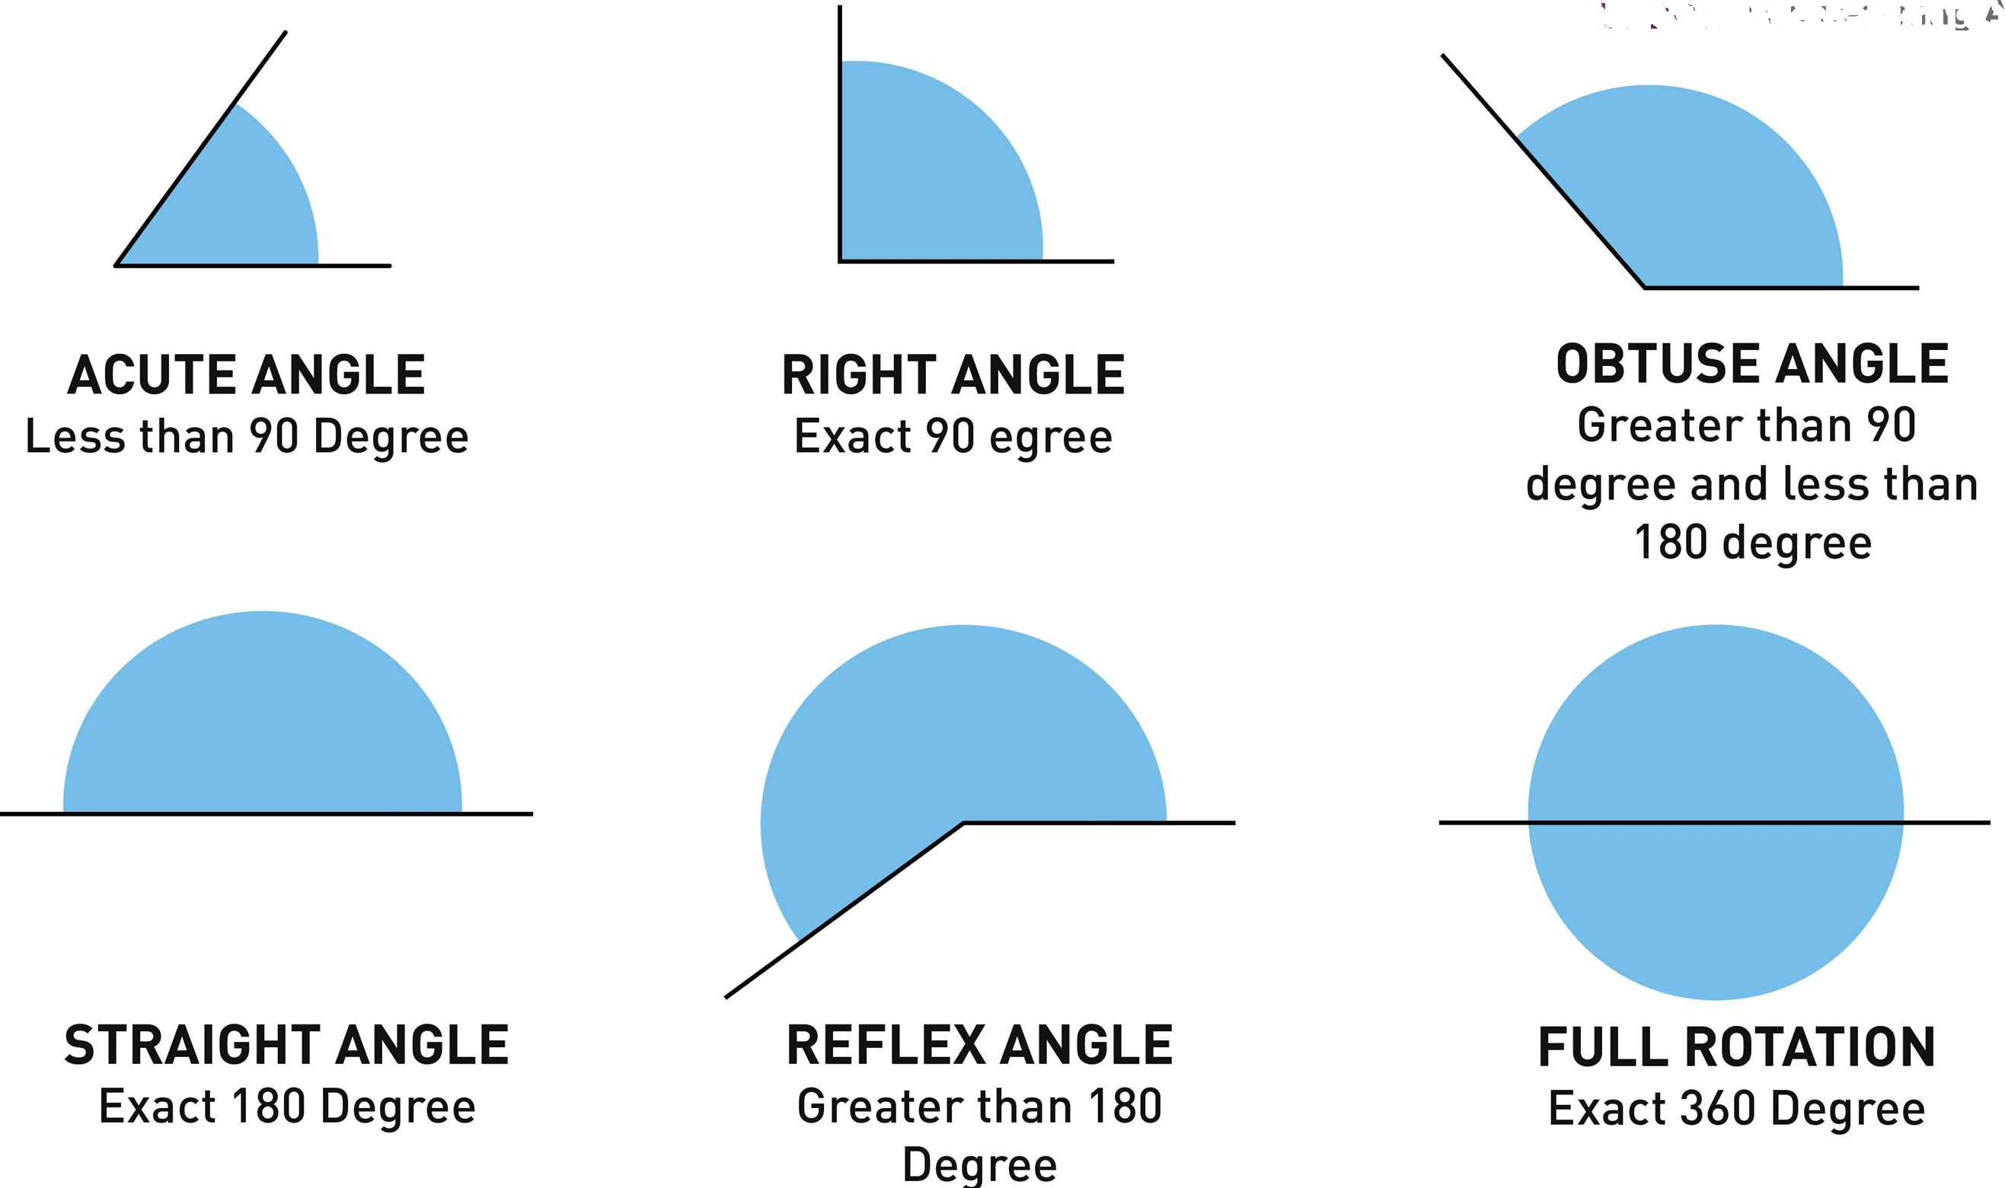
COMPLEMENTARY ANGLES
- Complementary angles are two angles that have a sum of 90 degrees.
- To determine the complement, subtract the given angle from 90.
- There are two types of complementary angles, adjacent and non adjacent
- Adjacent complementary angles are the angles that share a common side and vertex and are side by side and the right angle is divided into 2 angles that are adjacent to each other creating a pair of adjacent, complementary angles as shown below.
- Non adjacent - The angles do not share a common side.
Examples
This first diagram shows complementary angles that are adjacent, meaning that the angles share a side and a vertex, or the corner point of the angle.
Since 65+25 = 90, angles STA and ATR are complementary.
The next diagram shows two complementary angles that are not adjacent, but are in the same figure. Angles GDO and DOG are complementary because 70 +20 = 90. Angle DOG is a right angle as indicated by the little box we see at the vertex of DOG.

EXERCISE
- Find the value of x degrees and the angles in the figure below.
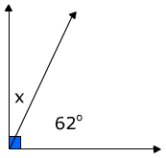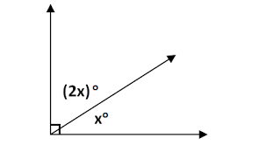
- Find the value of x degrees and the angles in the diagram below.
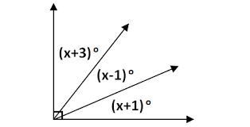
- x and y are complementary angles. Given x = ${35}^{o}$, find the value y.
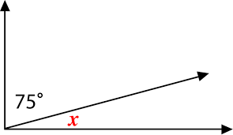
- Find the complementary angle of each of the following angles
  - $7^{o}$
  - ${38}^{0}$
SUPPLEMENTARY ANGLES
Supplementary angles are two angles that add up to 180 degrees on a straight line. They don’t have to be next to each other, just so long as the total is 180 degrees.
PROPERTIES OF SUPPLEMENTARY ANGLES
- The two angles are said to be supplementary angles when they add up to 180 degree. The two angles together make a straight line but the angles don’t have to be together.
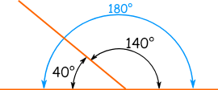
- S of supplementary angle stands for “Straight “line. This means that it forms 180 degrees
- Supplementary angles may be classified as either adjacent or non adjacent. The adjacent supplementary angle shares the line segment or arm with each other whereas the non- adjacent supplementary angles do not share the line segment or arm.
- 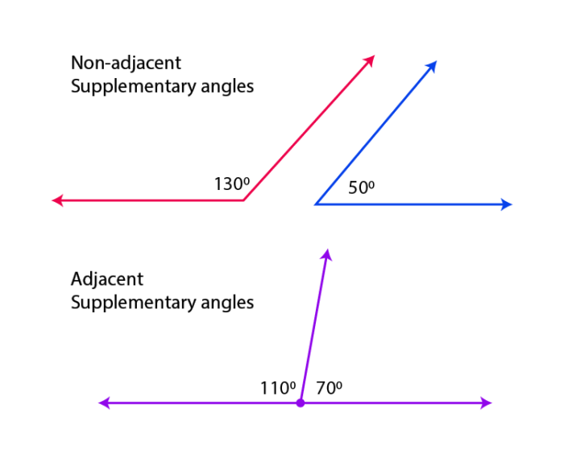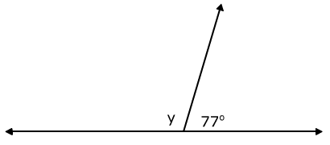
EXERCISE
- Find the value of unknown angles in the diagrams belowa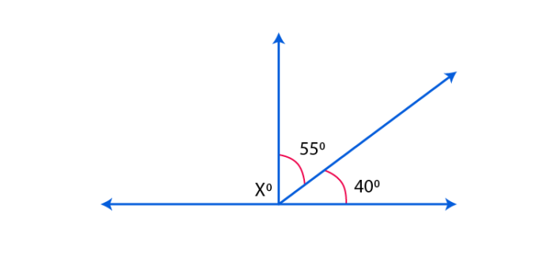 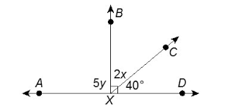
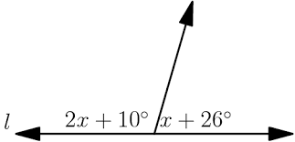
- x and y are supplementary angles. Given x = ${72}^{o}$, find the value of y.
- Find the measure of the supplementary angle for each of the following angles
  - ${124}^{o}$
  - ${75}^{o}$
PARALLEL LINES
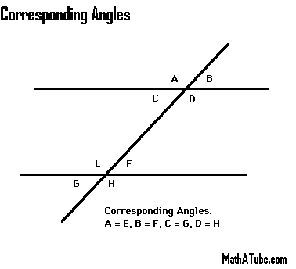
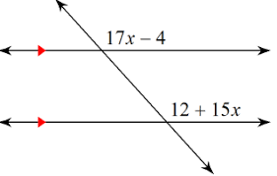
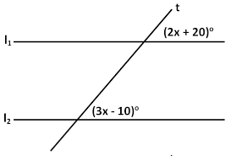
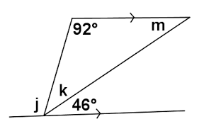
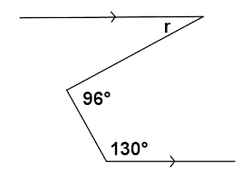

TYPES OF TRIANGLES
- ISOSCELES TRIANGLE
Isosceles triangle is a triangle which has two equal sides and two equal angles. In other words, an isosceles definition states it as a polygon that consists of two equal sides, two equal angles, three edges, three vertices and the sum of internal angles of a triangle equal to ${180}^{0}$.
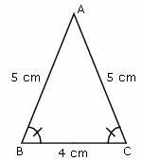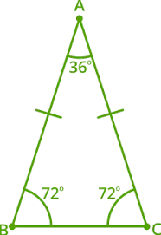
In the triangle ABC above, sides AB = AC and angle ABC =angle ACB.
Other examples
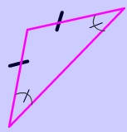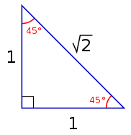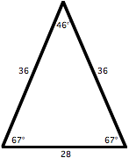

ISOSCELES TRIANGLE PROPERTIES
- Two sides are congruent to each other.
- The third side of an isosceles triangle which is unequal to the other two sides is called the base of the isosceles triangle.
- The two angles opposite to the equal sides are congruent to each other. That means it has two congruent base angles and this is called an isosceles triangle base angle theorem. The angle which is not congruent to the two congruent base angles is called an apex angle.
- The altitude from the apex of an isosceles triangle bisects the base into two equal parts and also bisects its apex angle into two equal parts.
- The altitude from the apex of an isosceles triangle divides the triangle into two congruent right angled triangles.
- Area of Isosceles triangle = $\frac{1}{2}$ x base x altitude.
- Perimeter of Isosceles triangle = sum of all the three sides.
RIGHT ISOSCELES TRIANGLE
This triangle which has a right angle (${90}^{0}$) and also two equal angles.
PROPERTIES OF ISOCELES RIGHT ANGLED TRIANGLE
- One angle is a right angle and the other two angles are both 45 degrees.
- The longest side is the hypotenuse and is opposite the right angle.
- The opposite and adjacent sides are equal.
- The area is half product of the opposite and adjacent sides.
- The centre of the circumscribing circle is the midpoint of the hypotenuse.
Example of the diagram showing right isosceles triangle
EXERCISE A
- Find the angle x and angle A in the diagram below.
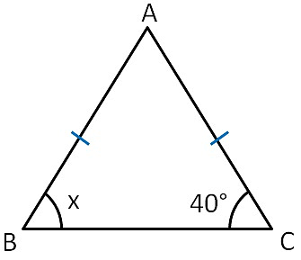
- Find angle X in the figure below.
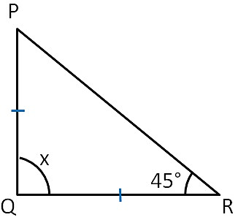
- Find angle x below

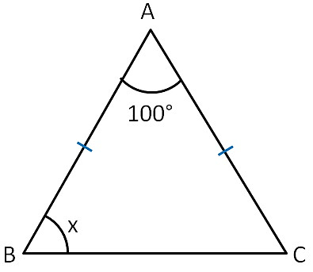
- Find angle x below
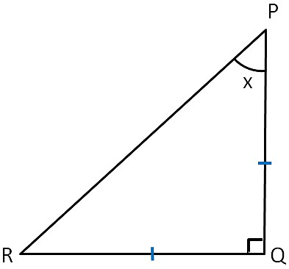
- Find angle x below
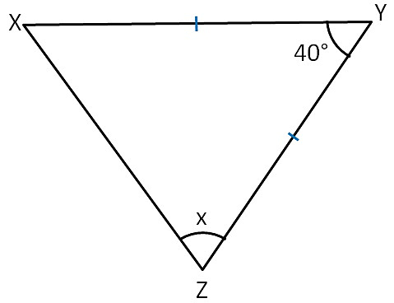
- Find angle x below
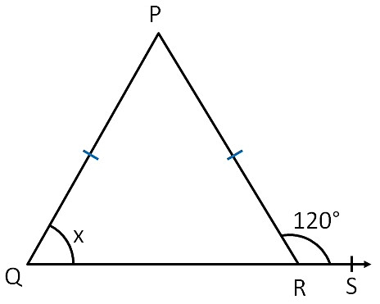
- Find angle x below
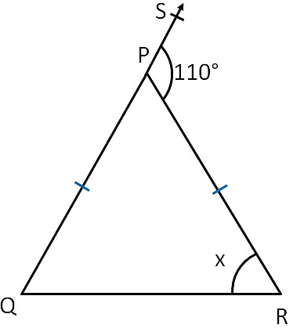
- Find angle x below
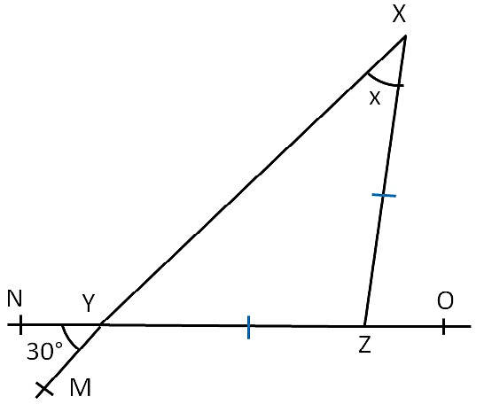
- Find angle x and y below
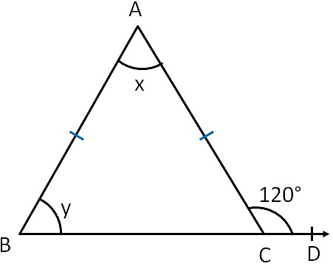
- Find angle x and y below
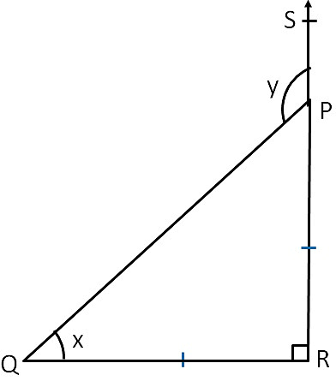
- Find angle x and y below
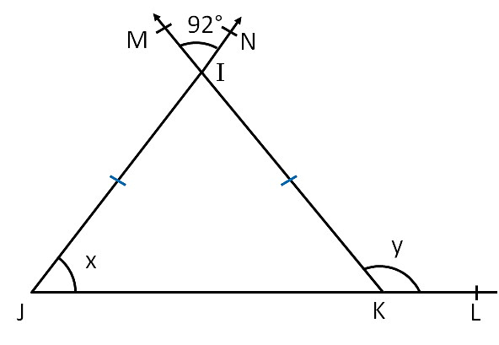
- Find x and y from the given figure below
- ABC and CDE are isosceles triangles. Find the size of angle CED.
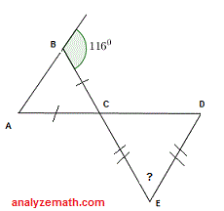
- Triangle ABC is isosceles where AC= CB. AC = 6A-8 and CB= 4a-2. Find AC.
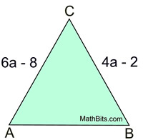
- Triangle BUG is isosceles. Angle BUG = 3x and angle UBG = x +10. Find angle BUG.
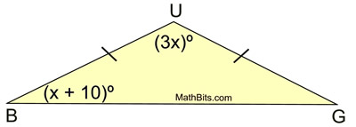
- Find the value of the vertex angle in the diagram below.
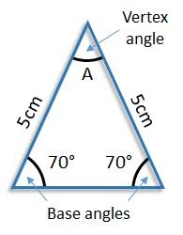
- $∆$GAB is isosceles. The exterior angle at point B measures${138}^{0}$.
$Find <A$.
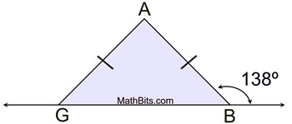
- Find the value of x and y in the following diagram below.
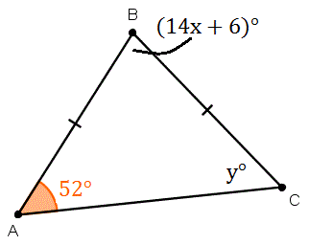
- TG= TR, $<S$ =2X-10; $<$STG = x +10 and$<SGT=6x$. Find $<S$ and$<TGR$.
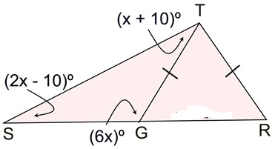
EXERCISE B
- If an isosceles triangle has lengths of two equal sides as 5cm and base as 4cm and an altitude is drawn from the apex to the base of the triangle. Then find its area and perimeter.
- In the figure below, find the values of x and y.
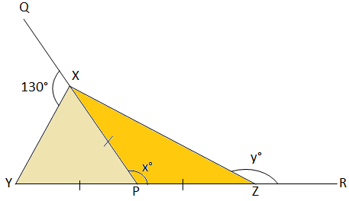
EQUILATERAL TRIANGLE
Equilateral triangle is a triangle which has three congruent sides (three equal sides) and three congruent angles (three equal angles). This means that all three sides are equal and all three angles are equal. Each angle is ${60}^{0}$ . The Equilateral triangle is shown by the diagram below. In the triangle ABC above, sides AB=BC=CA and angle ABC= BCA=CAB =${60}^{0}$.
PROPERTIES OF EQUALITERAL TRIANGLE
- All three sides and three angles are equal.
- The three angles are ${60}^{0}$ each.
EXAMPLES
- 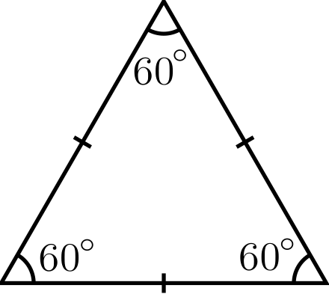
- 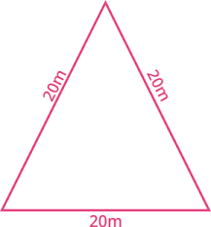
- Find the area of an equilateral triangle whose perimeter is 12cm
- Find the area of an equilateral triangle whose side is 7cm
- Find the area of an equilateral triangle whose side is 28cm.
- Calculate the height of an equilateral triangle with a side of 10 com
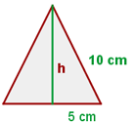
- SCALENI TRIANGLE
The scale triangle has no congruent sides (No equal sides and No equal angles). In other words, each side must have a different length. The scalene triangle is shown in the figure below.
PROPERTIES OF SCALE TRIANGLES
- All sides of the scalene triangle are unequal
- All angles of a scalente triangle are unequal.
RIGHT SCALENE TRIANGLE
This is a triangle which has one right angle and no equal sides.
- OBTUSE TRIANGLE
The obtuse Triangle is a triangle which has an obtuse angle (an obtuse angle has more than${90}^{0}$). In the picture below, the shaded angle is the obtuse angle that distinguishes this triangle. Since the total degrees in any triangle is${180}^{0}$, an obtuse triangle can only have one angle that measures more than ${90}^{0}$
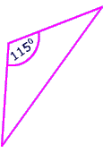
- Acute triangle
The Acute Triangle has three acute angles (an acute angle measures less than${90}^{0}$)
PROPERTIES OF ACUTE TRIANGLE
- The interior angles of a triangle are always less than ${90}^{0}$
- In acute triangle, the line drawn from the base of the triangle to the opposite vertex is always perpendicular.
- A triangle has three vertices.
- The interior angles of a triangle are formed when two edges of a triangle meet.
Example
In the figure below angles A, B and C are all less than 90 degrees.
a. 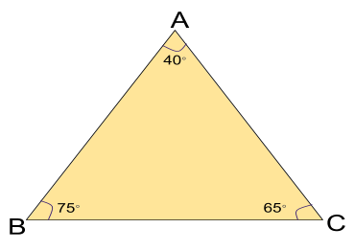
b. 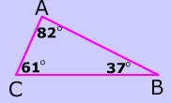 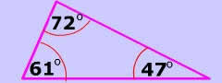

EXAMPLES OF THE PYTHAGOREAN THEOREM
When you use the Pythagorean Theorem, just remember that the hypotenuse is always ‘c’ in the formula above. Look at the following examples to see pictures of the formula.
VERTICALLY OPPOSITE ANGLES
Vertical angles are opposite angles are equal to each other. They are two pairs of angles which are formed by two intersecting lines.
The figure below shows the vertically opposite angles.
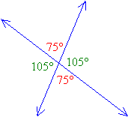
When two lines intersect they form two pairs of opposite angles, A + C and B + D. Another word for opposite angles are vertical angles.
Vertically angles are always congruent which means that they are equal.
EXERCISE
Given the diagram below, determine the values of the angles x, y and z.
PARALLEL LINES
When parallel lines get crossed by another line which is called transversal, you can see that many angles are the same as in this example
Angles that are in the area between the parallel lines like angle 2 and 8 above are called interior angles where as the angles that are on the outside of the parallel lines like 1 and 6 are called exterior angles.
Angles that are on the opposite sides of the transversal are called alternate angles, for example 1 and 8.
When a transversal intersects with two parallel lines eight angles are produced.
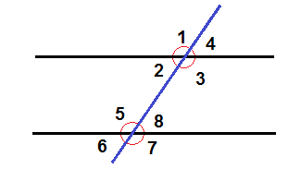
- Corresponding angles- They are equal
Corresponding angles are congruent-equal. All angles that have the same position with regards t the parallel lines and the transversal are corresponding pairs.
Examples
- 3 and 7
- 4 and 8
- 2 and 6
- 1 and 5
- Alternate angles- When a line intersects a pair of parallel lines alternate angles are formed. Alternate interior angles are equal to each other.
Alternate angles are angles that are on the opposite sides of the transversal. They are equal angles.
Examples
- 2 and 8
- 3 and 5
- Allied angles (Interior angles) - They are angles that add up to 180 degrees.
Examples
- 3 + 8 = 180 degrees ( Allied angles)
- 2 + 5 = 180 degrees ( Allied angles)
EXAMPLE
Given the diagram below, determine the values of the angles b, c, d, e, f, g and h.
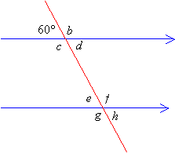
Solution
Step 1: b is a supplement of 60 degrees
Therefore b+ 60 = 180
b = 180 degrees - 60 degrees
= 120 degrees
Step 2 : b and c are vertical angles
Therefore, c =b =120
Step 3 : d and 60 degrees are vertical angles
Therefore, d = 60 degrees
Step 4: d and e are alternate interior angles
Therefore, e = d = 60 degrees
Step 5 : f and e are supplementary angles.
Therefore, f + 60 =180 degrees.
Step 6: f and e are supplementary angles
Therefore, f + 60 = 180
f = 180 degrees - 60 degrees
= ${120}^{o}$
REGULAR POLYGON
Regular polygon is a polygon that is equiangular (all angles are equal in measure) and equilateral (all sides have the same length).
A polygon can either be a convex or a concave.
A convex polygon has all angles less than 180 degrees
A concave polygon has at least one angle greater than 180 degrees.
EXAMPLES OF REGULAR POLYGON
Name of the polygon | Number of sides
Triangle | 3
Quadrilateral | 4
Pentagon | 5
Hexagon | 6
Heptagon | 7
Octagon | 8
Nonagon | 9
Decagon | 10
SUM OF ENTERIOR ANGLES
The sum of interior angle of a convex polygon with n sides can be found using the following formula :
The sum of Interior angle =$\left(2n-4\right){90}^{o}$
OR The sum of interior angles $=\left(n-2\right){180}^{o}$
EXAMPLES
The value of the interior angles of the regular polygon can be found using or calculated the following formula :
Interior angle = $\left(1-\frac{2}{n}\right)$ x 180 degrees or
= $\frac{180\left(n-2\right)}{n}$ degrees

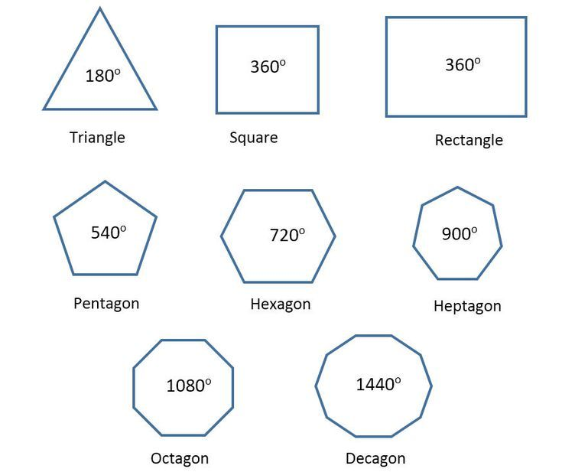
EXAMPLES
Find the angle sum of each of the following regular polygons
Regular polygon | formula= $\left(n-2\right){180}^{o}$
- Regular triangle$\left(3 sided polygon\right)$ | =$\left(3-2\right){180}^{o}=$ ${180}^{0}$
- Regular quadrilateral$\left(4 sided polygon\right)$ | $\left(4-2\right){180}^{o}=$ ${360}^{o}$
- Regular Pentagon$\left(5 sided polygon\right)$ | $\left(5-2\right){180}^{o}$= ${540}^{0}$
- Regular Hexagon$\left(6 sided polygon\right)$ | $\left(n-2\right){180}^{o}$= ${720}^{0}$
- Regular Heptagon$\left(7 sided polygon\right)$ | $\left(n-2\right){180}^{o}$= ${900}^{0}$
- Regular Octagon$\left(8 sided polygon\right)$ | $\left(n-2\right){180}^{o}$=${1080}^{o}$
INTERIOR ANGLE
The value of the interior angles of the regular polygon can be found using or calculated the following formula :
Interior angle = $\left(1-\frac{2}{n}\right)$ x 180 degrees or
= $\frac{180\left(n-2\right)}{n}$ degrees
EXAMPLE
Find the value of the interior angle of each of the following regular polygon
Number of sides | Formula | Calculations
- 3 sided polygon | $\left(1-\frac{2}{n}\right)$ x 180 | $\left(1-\frac{2}{3}\right)$ x 180 = ${60}^{o}$
- 4 sided polygon | $\left(1-\frac{2}{n}\right)$ x 180 | $\left(1-\frac{2}{4}\right)$ x 180 = ${90}^{o}$
- 5 sided polygon | $\left(1-\frac{2}{n}\right)$ x 180 | $\left(1-\frac{2}{5}\right)$ x 180 =${ 108}^{o}$
- 6 sided polygon | $\left(1-\frac{2}{n}\right)$ x 180 | $\left(1-\frac{2}{6}\right)$ x 180 =${120}^{o}$
- 7 sided polygon | $\left(1-\frac{2}{n}\right)$ x 180 | $\left(1-\frac{2}{7}\right)$ x 180 = ?
- 8 sided polygon | $\left(1-\frac{2}{n}\right)$ x 180 | $\left(1-\frac{2}{8}\right)$ x 180 =${60}^{o}$
- 9 sided polygon | $\left(1-\frac{2}{n}\right)$ x 180 | $\left(1-\frac{2}{9}\right)$ x 180 =${60}^{o}$
- 10 sided polygon | $\left(1-\frac{2}{n}\right)$ x 180 | $\left(1-\frac{2}{10}\right)$ x 180 =${60}^{o}$
Exercise
The angles of a triangle have the ratio 3:2: 1. What is the measure of the smallest angle?
EXERCISE
Find the value of each interior angle of a regular polygon with the following number of sides

- 15
- 11
- 15
- 22
- 18
- 24

EXTERIOR ANGLE
The exterior angle is the angle between any side of a shape and a line extended from the next side.
All the Exterior Angles of a polygon add up to${ 360}^{o}$.
Each exterior angle can be found by the formula = $\frac{{360}^{o}}{n}$
EXAMPLE
What is the exterior angle of the following regular polygons?
Regular polygon | Exterior angle
- Regular triangle$\left(3 sided polygon\right)$ | $\frac{360}{3}$ = ${120}^{0}$
- Regular quadrilateral$\left(3 sided polygon\right)$ | $\frac{360}{4}$ = ${90}^{o}$
- Regular Pentagon$\left(3 sided polygon\right)$ | $\frac{360}{5}$ = ${72}^{0}$
- Regular Hexagon$\left(3 sided polygon\right)$ | $\frac{360}{6}$ = ${60}^{o}$
EXERCISES
- Find the sum of the interior angles of a regular polygon with the following numbers of sides

- 10
- 14
- 4
- 18
- 20
- 13
- 16
- 12

EXAMPLE
The sum of interior angle of a regular polygon is${1800}^{o}$. Find the number of sides in the polygon.
$\left(2n-4\right){90}^{o}$ = ${1800}^{o}$
2n$-4$ = $\frac{{1800}^{o}}{90}$ = 20
2n $=$ 24
n = 12
A polygon with 12 sides is called a dodecagon.
EXERCISE
How many sides does a polygon have if the sum of the interior angle is

- ${3240}^{o}$
- ${2520}^{o}$
- ${2340}^{o}$
- ${540}^{o}$
- ${720}^{o}$

- ${900}^{o}$

EXAMPLE
Four angles of a hexagon are${\left(x+18\right)}^{o}$, ${\left(2x-10\right)}^{o}, {\left(3x+25\right)}^{o} and {\left(x+42\right)}^{o}$. The fifth and sixth angles are ${\left(70\right)}^{o} and {\left(50\right)}^{o}$ respectively. Find the last and smallest angles of hexagon.
Sum of interior angle of hexagon = ${\left(2n-4\right)90}^{o}$
= ${\left(2 x 6-4\right)90}^{o}$
= ${\left(12-4\right)90}^{o}$
= 8 x${90}^{o}$
= ${720}^{o}$
${\left(x+18\right)}^{o}$+ ${\left(2x-10\right)}^{o}+ {\left(3x+25\right)}^{o}+{\left(x+42\right)}^{o}$+ ${\left(70\right)}^{o}+{50}^{o}$=${720}^{o}$
7x + ${195}^{o}$ = ${720}^{o}$
7x = ${720}^{o}$- ${195}^{o}$
7x = ${525}^{o}$
x = ${195}^{o}$
The angles of the hexagon are,${\left(2x-10\right)}^{o}, {\left(3x+25\right)}^{o} and {\left(x+42\right)}^{o}$. The fifth and sixth angles are ${\left(70\right)}^{o} and {\left(50\right)}^{o}, that$is ${ 93}^{o}, {140}^{o}, {259}^{o}, {117}^{o},{70}^{o} and {50}^{o}$
EXERCISE
- Find the largest and smallest angles of a hexagon whose angles are${ \left(x+20\right)}^{o}, {\left(2x-40\right)}^{o}, {\left(2x+30\right)}^{o}$, ${\left(x-60\right)}^{o}{, \left(2x-124\right)}^{o}$ and ${110}^{o}$
${ \left(x+20\right)}^{o}+ {\left(2x-40\right)}^{o}+ {\left(2x+30\right)}^{o}$+ ${\left(x-60\right)}^{o}{+\left(2x-124\right)}^{o}$+ ${110}^{o}=720$
8x +160-224 = 720
8x-64 = 720
8x =784
x = 98
The angles are ${ \left(98+20\right)}^{o}, {\left(2 x 98-40\right)}^{o}, {\left(2x 98+30\right)}^{o}$, ${\left(98-60\right)}^{o}{,\left(2x 98-124\right)}^{o}$, ${110}^{o}$
118, 156,226,38, 72,110
The largest and smallest angles are 226 degrees and 38 degrees
- The exterior angle of a regular polygon is ${20}^{o}$. How many sides does it have?
Number of sides = $\frac{Sum of exterior angles}{Size of each exterior angle}$
= $\frac{{360}^{0}}{{20}^{0}}$
= 18
- The exterior and interior angles of a regular polygon are in the ratio 1 : 9. Calculate the exterior angle and hence the number of sides.
Sum of exterior and interior angles:
9x + x = 180 (Supplementary angles
10x = 180
x = 18 degrees
9x = 9 x 18
= 162
- Calculate the number of sides of a regular whose interior angles are each ${160}^{o}$.
$\left(1-\frac{2}{n}\right)$ x 180 = 160
$1-\frac{2}{n}$ = $\frac{8}{9}$
1 - $\frac{8}{9}$ = $\frac{2}{n}$
$\frac{1}{9}$ = $\frac{2}{n}$
n = 18
- An interior angle of a regular polygon is ${140}^{o}$ greater than the exterior angle. Calculate the size of each exterior and the number of sides of the polygon.
Let exterior angle be x
The Interior angle = 140 +x
x +140 + x = 180 (supplementary angles)
2x + 140 = 180
2x = 180-140
2x = 40
x = 20 degrees
- Each interior angle of a regular polygon is five times each exterior angle.
- What is the size of exterior angle?
- How many sides does the polygon have?
Let exterior angle be = x
Then Interior angle = 5x
5x +x = 180
6x = 180
x = 30
Number of sides of the polygon = $\frac{360}{30}$
= 12
RECTANGLE
PERIMETER OF THE RECTANGLE
The perimeter ,Poor the rectangle is the distance around the rectangle .If you started at one corner and walked around the rectangle, you would walk L+W+L+W units or two lengths and two widths.
Then the perimeter of the rectangle
P = L+W+L+W
P= 2L+2W
PROPERTIES OF RECTANGLES
- Rectangles have four sides and four right angles
- The lengths of opposite sides are equal.
- The perimeter, P, of a rectangle is the sum of twice the width.
- The area of a rectangle is the length times the width.
A = L X W
EXAMPLES
- Find the perimeter and area of the rectangle of length 17cm and breadth 13cm.
Perimeter of the rectangle = 2 (L+B)
= 2 (17+13)
= 2 x 30cm
= 60cm
Area of the rectangle, A = Length x Breadth
= 33 x 13${cm}^{2}$
= 221${cm}^{2}$
- Find the breadth of the rectangular plot of land whose area is 660$m^{2}$ and whose length is 33. Find its perimeter.
Breadth of the rectangular plot = $\frac{Area}{Length}$
= $\frac{660m^{2}}{33m}$
= 20m
Perimeter of the rectangular plot = 2(L+B)
= 2 (22+20)m
= 2 x 53m
= 106m
- Find the area of the rectangle if its perimeter is 48cm and its breadth is 6cm.
Perimeter of the rectangle = 2(L+B)
48cm =2 (L+6)
$\frac{48}{2}$ = L +6
24 = L +6
Length, L = 24-6
L= 18cm
Now, area of the rectangle = L X B
= 18cm X 6cm
= 108cm
- Find the breadth and perimeter of the rectangular if its area is 96${cm}^{2}$ and the length is 12cm.
Area of the rectangle = Length x Breadth
96 = 12 x Breadth
Breadth, B = $\frac{96}{12}$
= 8cm
Therefore, the Perimeter of the rectangle = 2(L+B)
= 2(12+8)cm
= 2 x 20
= 40cm
- The length and breadth of a rectangular courtyard is 75m and 32m. Find the cost of leveling it at the rate of K3 per square meter. Also, find the distance covered by a boy to take 4 rounds of the courtyard.
Perimeter of the courtyard = 2(L+ B)
= 2 (75 +32)m
= 2 x 107m
= 214m
Distance covered by the boy in taking 4 rounds = 4 x 214m
=856m
Area of the courtyard = 75m x 32m
= 2400$m^{2}$
For 1$m^{2}$, the cost of leveling = K3
For 2400$m^{2}$, the cost of leveling = K3 x 2400
=K7200
- A floor of the room 8m and 6m wide is to be covered by square tiles. If each square tile is 0.8m, find the number of tiles required to cover the floor. Also, find the cost of tiling at the rate of K7 per tile.
Area of the room = 8mx6m
= ${48m}^{2}$
Area of the tile = 0.8 x 0.8$m^{2}$
= 0.64$m^{2}$
Number of one square tile = $\frac{Area fo floor}{Area of tiles}$
= $\frac{48}{0.64}$
= 75 tiles
Fore tile , the cost of tiling is K7
For 7 tiles , the cost of tiling = (7 X k75)
= K525
- The length and breadth of the rectangle park are in the ratio 5:4 and its area is 2420$m^{2}$, find the cost of fencing the park at the rate of K10 per meter.
Let the common ratio be x
Then the length of rectangular park = 5x
Breadth of rectangular park = 4x
Area of rectangular park = 5x x4x
=20$x^{2}$
According to the question 20$x^{2}$ = 2420
$\frac{20x^{2}}{20}$ = $\frac{2420}{20}$
$x^{2}$ = 121
x = 11
Therefore, 5x = 5 x 11
5x =55
4x = 4 x 11
4x = 44
The perimeter of ther rectangular park = 2(L + B)
= 2 (55 + 44)
= 2 X 99
= 198CM
For 1 meter, the cost of fencing = K10
For 198m, the cost of fencing = K198 x 10
= K1980
- A wire in the shape of rectangle of length 25 cm and 17 breadth17cm is rebent to form a square. What will be the measure of each side?
Perimeter of rectangle = 2(25 + 17)cm
= 2 x 42
= 84cm
Perimeter of the square of side xcm = 4x
$∴$Perimeter of rectangle = Perimeter of square
84cm = 4x
x = 21.
$∴$Each side of square = 21cm
- How many envelops can be made out of a sheet of paper 1000cm by 75cm, supposing 1 envelope requires 20cm by 5cm piece of paper.
Area of the sheet = 100x 75 ${cm}^{2}$
= 7500${cm}^{2}$
Area of envelope = 20c x 5cm
= 100 ${cm}^{2}$
$∴$Number of envelopes that can be made = $\frac{Area of sheet}{Area pof envelope}$
=$\frac{7500{cm}^{2}}{100{cm}^{2}}$
PARALLELOGRAM
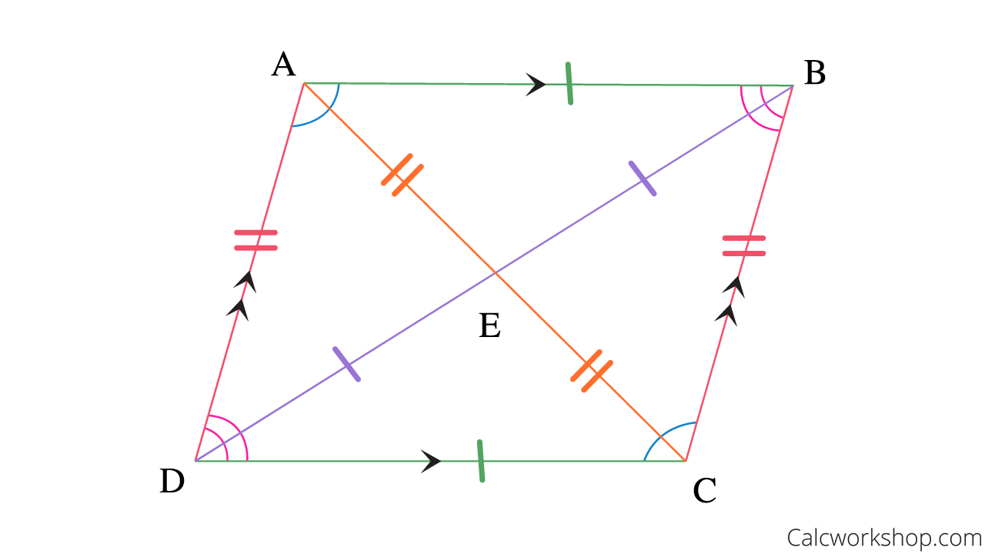
- Both pairs of opposite sides of parallelogram are parallel
- Both pairs of opposite sides of parallelogram are congruent
- Both pairs of opposite angle are congruent of parallelogram or equal.
- Consecutive angles (interior angles) of parallelogram are supplementary
- Diagonals bisect each other(cut each into equal parts)
PROPERTIES OF PARALLELOGRAMS EXPLAINED
- Opposite sides are parallel.
Segment AB is parallel to segment DC, and segment AD is parallel to segment BC.
- Opposite sides are congruent
Segment AB is congruent to segment DC and segment AD is congruent to segment BC.
- Opposite angles are congruent or equal
Angle A is congruent or equal to angle C and angle D is congruent angle B.
- Same-side interior or consecutive angles are supplementary.
Angles A and D are supplementary, angles A and B are supplementary angles B and C are supplementary, and angles D and C are supplementary
- Each diagonal of a parallelogram separates it into two congruent triangles
Triangle DAB is congruent to triangle DCB
- The diagonals of a parallelogram bisect each other.
Segment AE is congruent to segment CE and segment DE is congruent BE.

PERIMETER AND AREA OF THE PARALLELOGRAM
Perimeter of a parallelogram is the total distance of boundaries of the parallelogram.
Perimeter of the parallelogram = 2(a+b)
Area of the parallelogram = Base x Height
EXERCISE
- In the parallelogram ABCD below, angle B = ${\left(2x+15\right)}^{o}$ and angle $x^{o}.$Find $x^{o}$.
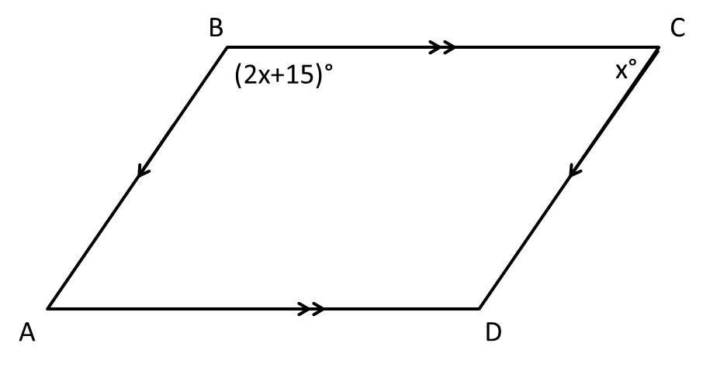
- ABCD below is a parallelogram. Find z.
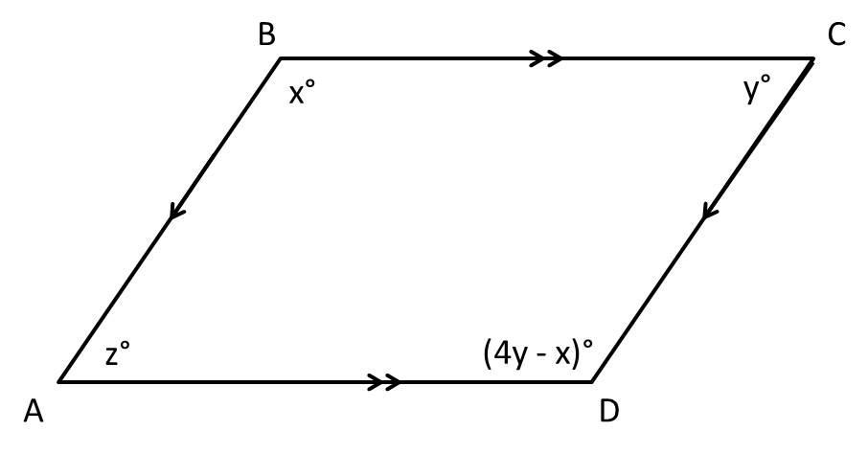
- ABCD below is a parallelogram. Find y
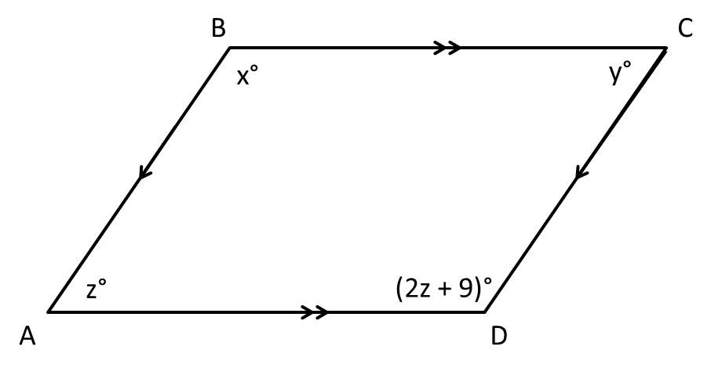
- Find the area of a parallelogram with a base of 12cm and a height of 5cm.
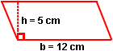
- Find the area of the parallelogram with a base of 7 m and a height of 19m.
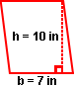

- The area of the parallelogram is 24 square centimeters and the base is 4centimeters. Find the height.
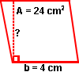
QUADRILATERALS
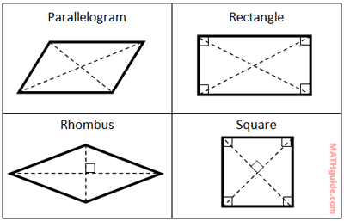
COMMERCIAL ARITHMETIC
CASH AND TRADE DISCOUNT
A trade discount is a discount given by the seller to the buyer as a deduction in the list price of the commodity. A trade discount is one that is allowed by the wholesaler to the retailer calculated on the list price of the product.
Cash discount is a deduction in the amount of invoice allowed by the seller to the buyer in return for immediate payment in order to facilitate bulk sales. It is allowed by the sellers to the customers at the time of making the payment of the purchases as a reduction in the invoice price of the commodity to facilitate a prompt payment and thereby to avoid the credit risk.
EXAMPLE
The selling price of the Television Set is K2, 900. The manufacturer offers its dealer a 40% trade discount. What are the amount of trade discount and net price?
Trade discount = List price x Trade discount rate
= K2,900 x $\frac{40}{100}$
= k1160
Net Price = K2,900 $-$ K1160
= K1740
The price of the computer after the discount is K18, 000. With 30% trade discount is offered; find the list price of the bag.
The list price of the computer = Net Price + Trade discount
= K18,000 + (30% XK18,000)
= K18,000 +K5,400
= K23,400

Two shops are offering the same model of TV set for sale which had an original price of K36, 000.
Shop A is offering a discount of 8% followed by a special offer of 3% off that discounted price.
Shop B is offering a single discount of 11%.
Required:
What saving would be made by buying the set at the cheaper price?
Cost at Shop A = 92 x 36000

=K33120 before offer
= K33120 x 97
100 = K33120 x 97
= K32126.40 after offer
Cost at Shop B = 89 x 36000

= K32040.00
∴Saving by buying at Shop B
= K32126.40 – K32040.00
= K86.40
A businessman purchased a computer that was discounted at the rate of 8%. If the discounted price was K79, 650, find the original price of the computer, to the nearest Kwacha
K79,650 is 92% of the original price
Original price = $\frac{79,650 X 100}{92}$
= K86,576.07
= K86,576
Two shops are offering the same model of TV set for sale which had an original price of K36, 000.
Shop A is offering a discount of 8% followed by a special offer of 3% off that discounted price.
Shop B is offering a single discount of 11%.
Required:
What saving would be made by buying the set at the cheaper price?
Cost at Shop A = 92 x 36000

=K33120 before offer
= K33120 x 97
100 = K33120 x 97
= K32126.40 after offer
Cost at Shop B = 89 x 36000

= K32040.00
∴Saving by buying at Shop B
= K32126.40 – K32040.00
= K86.40
A food retailer purchases rice at a cost of K160 per kg and sells it at K360 per kg.
Required:
  - Calculate the gross profit received as a % of the selling price.
  - If the retailer offered 10% discount on the selling price, what would be the new selling price of the rice? (Give your answer to two decimal places).
Gross profit% = $\frac{360-160}{160}$ x 100
= 125%
New selling price at 10% discount = 360 x 90%
= K 324
- A sales assistant is paid a basic wage of K100 per week plus commission of 5% of the value of the goods sold. What will be the earnings in a week in which the assistant sells goods to the value of £1,890?
Earnings = Basic wage + commission
= £100 + 5% x K1,890
= £100 + 94.50
=£194.50
Exercise
- Two shops, A and B, are selling similar TV sets at a price of K96, 000. Shop A is offering a discount of 8% followed by a special offer at 3% off the discounted price. Shop B is offering a single discount of 11%.
Required:
What saving would be made by buying the set at the cheapest price?
- A food wholesaler purchased some fresh vegetables for K1,700 and sold them for K2,000.
  - Calculate the percentage profit received.
  - If the wholesaler offered a 17.65% discount on the selling price, what would be the new selling price of the fresh vegetables?
COMMISSION
Commission the reward paid employees for selling goods and services.
EXAMPLE
A certain girl who sells cell phone airtime gets a 5% on sales. If she sold K25, 000 worth of airtime, how much commission does she get?
Commission = percentage x total sales
= 5% of K125,000
= 0.05 x K125,000
= K1,250
The gets a commission of K1,250.
- A used car salesperson can be paid using two methods
Method X uses straight commission of 3.5% of the selling price of all vehicles sold.
Method Y uses a fixed amount of K2, 500 per week plus commission of 1.5% of the selling price of all vehicles sold. If the total selling price of cars sold in each week is on average K200, 000, calculate which method of commission the salesperson would prefer.
- A salesperson selling used cars can be paid using two methods of commission.
Method X uses straight commission of 3.5% of the selling price of all the vehicles sold. Method Y uses a fixed amount of K25, 000 per week plus a commission of 1.5% of the selling price of all the vehicles sold.
Required:
If the total selling price of cars sold in each week is, on average, K2 million, advise the salesperson which method of commission to choose.
- A salesperson earns a basic wage of K1, 200 per month, plus commission on the value of goods sold in that month. In a particular month, the total value of goods sold by the salesperson was K18, 000 and the total wage received was K1, 470. Calculate the rate of commission (as a percentage) that the salesperson earns on the value of goods sold each month.
ELECTRICAL BILLS
- Electricity bills are charged per kwh (kilowatt-hours0 which is the unit of electricity.
- The difference between the readings of the first and last days of the month gives the number of units used.
- There is also a constant amount called the service charge which is added to every monthly bill whether you used electricity or not
Monthly electricity bill = $\left(No of units x cost per unit\right)+ Service charge$
EXAMPLE
Study the table below and use it to answer the question that follows.
Name | old meter reading | New meter reading | No of units used | Service charge | Cost per unit
Mr. Sauka | 9058 | 11003 | 1945 | K750 | K30
Mr. Mato | 41 | 16609 | 2500 | K1200 | K25
Find the monthly bill for
- Mr. Sauka
Monthly electricity bill = $\left(No of units x cost per unit\right)+ Service charge$
Number of units = New reading $- Old reading$
= $\left(11003-9058\right)$
= 1945
Monthly electricity bill = $\left(1945 x K30\right)+ K750$
= K58,350 + K750
= K59,100
- Mr. Mato
Monthly electricity bill = $\left(No of units x cost per unit\right)+ Service charge$
Number of units = New reading $- Old reading$
= $\left(16609-4109\right)$
= 12500
Monthly electricity bill = $\left(12,500 x K25\right)+ K1200$
= K58,350 + K750
= K59,100
EXECRISE
Calculate the electricity bill for Professor Mvula if her new reading is 43,238 and the old reading was 42,782. She pays a fixed charge of K678 plus K22 per kilowatt-hour of electricity used.
WATER BILLS
- Water bills are calculated basing on the number of units used as well as the service charge in place.
- However, the service charge is higher in low density areas like Nyambadwe in Blantyre, Chimaliroin Mzuzu and Area 10 in Lilongwe than in high density areas like Ndirande in Blantyre, Masasa in Mzuzu and Chilinde in Lilongwe.
- Calculations for water bills are the same as for those of electricity.
Monthly water bill = $\left(No of units x cost per unit\right)+ Service charge$
Number of units = New reading $- Old reading$

EXAMPLE
Mr. St Gideon stays in a low -density area where the service charge is K2, 000 and the water is charged at K39 per kl. Work out his bill if his consumption is 82kl.
SOLUTION
Monthly water bill = $\left(No of units x cost per unit\right)+ Service charge$
Number of units = $\left(82 x K32\right)$ + K2,000
= K3198 + K2,000
=K5,198
TELEPHONE BILLS
- Telephone bills are calculated basing on the number of units used as well as the service charge in place.
- Calculations for telephone bills are the same as for those of electricity.
- Monthly telephone bill = $\left(No of units x cost per unit\right)+ Rental charge$
- Number of units = New reading $- Old reading$
- In telephone bills the service charge is called the rental charge.
EXAMPLE
Study the table below. Study it and answer the questions that follow.
 | No. of Units | Cost per unit | Rental charge
Mr. Lungu | 608 | K36 | K317
Required
Calculate the telephone bill for Mr. Lungu.
SOLUTION
Monthly telephone bill = $\left(No of units x cost per unit\right)+ Rental charge$
= $\left(608 X 36\right)$ + K317
= K22608 + K317
= 22925
VALUE ADDED TAX (VAT)
- Value Added Tax is a tax levied on the difference between a commodity’s price before taxes and its cost of production. It is the component of Customs duty.
- VAT is an indirect sales tax on the domestic consumption of goods and services except those that are zero rated such as food and essential drugs.
- VAT is charged as an addition to the selling price of a business’s goods and services.
- Businesses have to pay the VAT they receives from customers to customs and excise department. The standard rate of VAT is set by parliament and it is currently at 16.5%
EXAMPLES
- Calculate VAT payable on an article costing K8,000 before VAT is added if the VAT is added at 16.5%
VAT at 16.5% = K8,000 X $\frac{16.5}{100}$
= K1,320
- Mr. Gideon pays K160, 675 inclusive of 16.5% VAT for a deep freezer. How much would the deep freezer cost without VAT?
Cost of deep freezer without VAT = K160,675 $-( \frac{16.5}{100} x K160,675)$
= K26,511.38
The cost without VAT = K160,675$-$K26,511.38
= K134,163.62
TAXATION- PAY AS YOU EARN CALCULATION
What does a salary comprise of?
It comprise of
- Basic pay- this is the amount that is based on some form of fixed pay structure within which each job is allocated to a certain pay level
- Gross pay- this is the amount that includes basic pay plus allowances.
- Net pay- this is the left over or take home pay an employee actually receives and is calculated by subtracting total deductions from the gross pay.
EXAMPLE
Suppose Mr. Philip receives K720, 000 as his annual salary. Calculate his net pay after deductions of tax using the following MRA Tax schedule.
MRA TAX SCHEDULE
1st k20,000 | Free or Zero
Next k3,000 | 15%
Excess over | 30%
SOLUTION
Annual salary K720,00
Monthly pay = $\frac{k720,000}{12 months}$
= K60,000
AMOUNT | TAX |  | REMAINDER
1ST K20,000 | - | O | (60,000-20,000)= K40,000
NEXT K3,000 | 3000 X 15% | K450 | (40,000-3,000) = K37,000
EXCESS K37,000 | 37,000 X30% | K11,100 | (37,000-37,000) = 0
 | TOTAL TAX | K11,550
Tax calculated = K11,550
Net Pay = Gross pay – Total deductions (Tax)
=K60,000 – K11,550
= K48,450
EXAMPLE TWO
Suppose Mr. Philip receives K720, 000 as his annual salary. Calculate his net pay after deductions of tax using the following MRA Tax schedule.
MRA TAX SCHEDULE
1st k20,000 | Free or Zero
Next k3,000 | 15%
Excess over | 30%
In addition to annual pay of K720, 000, Mr. Philip receives nontaxable allowances as follows: overtime for May, 2015, K10, 000, monthly house allowances K25,000, he is deducted a loan K90,000 on a monthly instalments of K24,000, pension scheme K5,000 and NICO Insurance premium of K8,000.
Required
- Calculate the gross pay and net pay for Mr. Philip for month of May, 2015.
- Prepare Mr. Philip’s pay slip for the month of May, 2015.
SOLUTION
Annual salary K720,00
Monthly pay = $\frac{k720,000}{12 months}$
= K60,000
Gross pay = K60,000 + non taxable allowances
= K60,000 + K10,000 +K25,000
= K95,000
Calculation of P.A.Y.E
AMOUNT | TAX |  | REMAINDER
1ST K20,000 | - | O | (60,000-20,000)= K40,000
NEXT K3,000 | 3000 X 15% | K450 | (40,000-3,000) = K37,000
EXCESS K37,000 | 37,000 X30% | K11,100 | (37,000-37,000) = 0
 | TOTAL TAX | K11,550
Tax calculated = K11,550
Net Pay = Gross pay – Total deductions
=K95,000 – (K11,550 + K5,000 + K8,000 + K24,000)
= K95,000 – K48,550
= K48,450
PREPARATION OF PAY SLIP
Name of Co | Mr. Philip | ID T/044 | District- Mzimba | Date 28/02/2015
CODE | DESCRIPTI0N | PAY | DEDUCTIONS | BALANCE
01 | Basic pay | K60,000
02 | Overtime | K10,000
03 | House allowance | K25,000
04 | Loan repayment |  | K24,000
05 | Pension |  | K5,000
06 | Insurance Premium |  | K8,000
07 | Tax (PAYE) |  | K11,550
 |  | Gross pay  K95,000 | DEDUCTION  K48,550 | NET PAY  K46,450
EXAMPLE THREE
Suppose that Mr. Thom of General Dealers Ltd gets K240, 000 as annual salary. In August, 2014, he had K500 accrued loan, K250 social club charges. Assuming that MRA has the following tax schedule.
MRA TAX SCHEDULE
1st k20,000 | Tax free
Next K1,500 | 10%
Next k1,500 | 15%
Excess over | 30%
- Determine Mr. Thom’s net pay for the month of August if General Dealers Ltd regards K4, 000 for his house allowance as taxable.
- Prepare Mr. Thom’s pay slip for the month of August, 2014.
SOLUTION
Annual salary K240,000
Monthly pay = $\frac{K240,000}{12 months}$
= K20,000
Gross pay = K20,000 + non taxable allowances
= K20,000 + K4,000
= K24,000
Calculation of P.A.Y.E
AMOUNT | TAX |  | REMAINDER
1ST K3,000 | - | O | (24,000-3,000)= K21,000
NEXT K1,500 | 1,500 X 10% | K150 | (21,000-1,500) = K19,500
NEXT K1,500 | 1,500 x 20% | K3,00 | (19,500-1,500) = K18,000
EXCESS K37,000 | 18,000 X30% | K5,400 | (18,000-18,000) = 0
 | TOTAL TAX | K5,850
Tax calculated = K5,850
Net Pay = Gross pay – Total deductions
=K95,000 – (K5,850 + K500 + K250)
= K95,000 – K6,600
= K17,400
PREPARATION OF PAY SLIP
Name of Co | Mr. Thom | ID T/044 | District- Mzimba | Date 28/02/2015
CODE | DESCRIPTI0N | PAY | DEDUCTIONS | BALANCE
01 | Basic pay | K20,000
02 | House allowance | K4,000
03 | Personal Loan |  | K500
04 | Social club charges |  | K250
05 | Tax (PAYE) |  | K5,850
 |  | Gross pay  K24,000 | DEDUCTION  K6,600 | NET PAY  K17,400
CUSTOMS AND EXCISE DUTY
Customs duty is a tax charged on the importation of goods. The price of the taxed commodity will be higher as a result of the tax. Calculate the custom duty the trader paid.
EXAMPLE
A trader was charged 20% as custom duty on second hand clothes which he bought for K54, 000. Calculate the custom duty the trader paid.
Custom duty = 20% of K54,000
= $\frac{20}{100}$ X K54,000
= K10,800
The trader paid Custom duty of K10,800
EXAMPLE
A business person paid customs duty of K15, 000. If he bought goods amounting to K125, 000, what was the rate of the duty?
Rate of custom duty = $\frac{15,000}{125,000}$ x 100
= 12%
STATISTICS
MEAN
What is the mean?
- The mean is the average of a set of numbers.
- It is found by adding up the set of numbers and then dividing the total by the number of data points in the set.
HOW TO FIND THE MEAN
The "Mean" is computed by adding all of the numbers in the data together and dividing by the number elements contained in the data set.
Mean = $\frac{\sum{X}}{N}$
Example:
Data Set = 2, 5, 9, 3, 5, 4, 7
Number of Elements in Data Set = 7
Mean = (2 + 5 + 9 + 7 + 5 + 4 + 3) / 7 = 5

EXAMPLES
Find the mean of 5, 7, 8 and 4.
Step1: Add up the numbers to give a total of 8 + 5+ 7 + 13
Total = 5+7+8+4
= 24
Mean = $\frac{24}{4}$
= 6
Median
The “Median” is the middle value of a set of ordered numbers. The "Median" of a data set is dependent on whether the number of elements in the data set is odd or even. First reorder the data set from the smallest to the largest then if the number of elements are odd, then the Median is the element in the middle of the data set.
If the number of elements is even, then the Median is the average of the two middle terms.
Examples: Odd Number of Elements
Data Set = 2, 5, 9, 3, 5, 4, 7
Reordered = 2, 3, 4, 5, 5, 7, 9
Median = 5
Example: Even Number of Elements
Data Set = 2, 5, 9, 3, 5, 4
Reordered = 2, 3, 4, 5, 5, 9 - the middle terms are 4 and 5
Median = (4 + 5) / 2 = 4.5 - the median is the average of the two middle terms
Mode
The "Mode" for a set of data is the value that occurs most often.The "Mode" for a data set is the element that occurs the most often.
It is not uncommon for a data set to have more than one mode.
This happens when two or more elements occur with equal frequency in the data set. A data set with two modes is called bimodal.
A data set with three modes is called trimodal.
Examples: Single Mode
Data Set = 2, 5, 9, 3, 5, 4, 7
Mode = 5
Examples: Bimodal
Data Set = 2, 5, 2, 3, 5, 4, 7
Modes = 2 and 5
Examples: Trimodal
Data Set = 2, 5, 2, 7, 5, 4, 7
Modes = 2, 5, and 7
Range
The "Range" is the difference between the largest value and smallest value in a set of data.
First reorder the data set from smallest to largest then subtract the first element from the last element.
Example:
Data Set = 2, 5, 9, 7, 5, 4, 3
Reordered = 2, 3, 4, 5
Range = (9 - 2) = 7
Worked Example 2
Five people play golf and at one hole their scores are 3, 4, 4, 5, and 7
For these scores, find
- The mean
- The median
- The mode
- The range.
- The numbers are already in order and the middle number is 4. So median = 4
- The score 4 occurs most often, so,
mode = 4
- The range is the difference between the smallest and largest numbers, in this case 3 and 7, so
range = 7 − 3
= 4
Calculate the , median and mode for the following set of numbers: 5,3,6,5,4,5,2,8,6,5,4,8,3,4,5,4,8,2,5,4
x | frequency (f) | cumulative frequency | fx
2 | 2 | 2 | 4
3 | 2 | 4 | 6
4 | 5 | 9 | 20
5 | 6 | 15 | 30
6 | 2 | 17 | 12
8 | 3 | 20 | 24
 | $$\sum{f=20}$$ |  | $$\sum{fx=96}$$
Mode =5
Median = $\frac{20}{2}$ =10
Mean, $\overline{x}$ =$\frac{\sum{fx}}{\sum{f}}$ =$\frac{96}{20}$
= 4.8
EXERCISE
- Find the mean, median, mode and range of each set of numbers below.
- 3, 4, 7, 3, 5, 2, 6, 10
- 8, 10, 12, 14, 7, 16, 5, 7, 9, 11
- 17, 18, 16, 17, 17, 14, 22, 15, 16, 17, 14, 12
- 108, 99, 112, 111, 108
- 64, 66, 65, 61, 67, 61, 57
- 21, 30, 22, 16, 24, 28, 16, 17
- In a survey of 10 households, the number of children was found to be 4, 1, 5, 4, 3, 7, 2, 3, 4, 1.
- State the mode.
- Calculate and also
- the mean number of children per household
- The median number of children per household.
- A researcher says: "The mode seems to be the best average to represent the data in this survey." Give ONE reason to support this statement.
- Eight people work in an office. They are paid hourly rates of £12, £15, £15, £14, £13, £14, £13, £13
Find
- the mean
- the median
- the mode.
4. In a singing contest, the scores awarded by eight judges were:
5.9 6.7 6.8 6.5 6.7 8.2 6.1 6.3
Using the eight scores, determine:
  - the mean
  - the median
  - the mode
- The marks of a student on seven examinations were 84, 91, 72,84,68,87 and 78. Find
- the mean
- the median of the marks.
- the mode
- Find the :
- mean
- median
- mode of the following numbers:
5,3,6,4,5,2,8,8,6,5,4,8,3,4,5,4,8,2,5,4,5.
- Find the mean, the median and the mode of the following numbers
- 3,5,2,6,5,9,5,9,5,2,8,6
- 51.6,48.7,50.3,49.5,48.5
- Calculate the mean of the numbers 2, 4, 6,8,3,7.
EXAMPLE
The goals scored by a hockey team in a season are shown in the table below.
Scores | Frequency
0 | 1
1 | 2
2 | 3
3 | 4
4 | 1
5 | 1
Find
- the mean
- the median
- the mode
SOLUTION
Score $\left(x\right)$ | $$\left(f\right)$$ | $$\left(Fx\right)$$ | Cumulative frequency
0 | 1 | 0 | 1
1 | 2 | 2 | 3
2 | 3 | 6 | 6
3 | 4 | 12 | 10
4 | 1 | 4 | 11
1 | 1 | 5 | 12
 | $\sum{f}$=12 | $\sum{fx}$= 29
Mean = $\frac{\sum{fx}}{N}$ = $\frac{29}{12}$
= 2.42
Position of the median = $\frac{12+1}{2}$
= $\frac{13}{2}$
= 6,5th
$∴$ Median = $\frac{2+3}{2}$
= 2.5
Mode = 3 (the value with the highest frequency)
- 35 girls in Form R were asked to write down the number of brothers each one of them had. The following information was gathered.
12 girls each had 5 brothers, 8 girls each had four brothers, 7 girls each had 1 brother and 3 had no brothers. Find the mean, median and the mode number of brothers.
- The table below shows the number of goals scored in 52 football matches.
Score | 0 | 1 | 2 | 3 | 4 | 5 | 6
Frequency | 5 | 10 | 15 | 10 | 6 | 5 | 1

Find the mean, mode and median score.
- From 40 potato plants, the yield of large potatoes was as shown in the table below. Copy and complete the table and calculate the mean, the median state the mode.
Number of large potatoes | 0 | 1 | 2 | 3 | 4 | 5
Frequency $\left(f\right)$ | 2 | 5 | 8 | 4 | 16 | 6 |  |  | $$\sum{f=}$$
$$\left(fx\right)$$ | 0 | 5 |  |  |  |  |  |  | $$\sum{fx}$$
- The mean masses of four groups students were as follows:
Groups | A | B | C | D
Number of students | 15 | 10 | 10 | 18
Mean mass $\left(kg\right)$ | 72 | 66.5 | 68.5 | 63
Find the mass of all students.
- In a set of 100 numbers, 20 were 4’s, 40 were 5’s, 30 were 6’s and the remainder were 7’s. Make a frequency table for the information and calculate the mean.
BAR GRAPH
A Bar Graph (also called Bar Chart) is a graphically display of data using a graphically display of data using bar. In other words, bar graph is a graph that presents categorical data with rectangular bars with heights or lengths proportional to the values that they represent. The bars can be plotted vertically or horizontally. A vertical bar chart is sometimes called a column chart.
EXAMPLE
In a firm of 400 employees, the percentage of monthly salary saved by each employee is given in the following table.
Savings (in percentage) | Number of employees (frequency)
20 | 105
30 | 199
40 | 29
50 | 73
Total | 400
Represent it through a bar graph.
SOLUTION
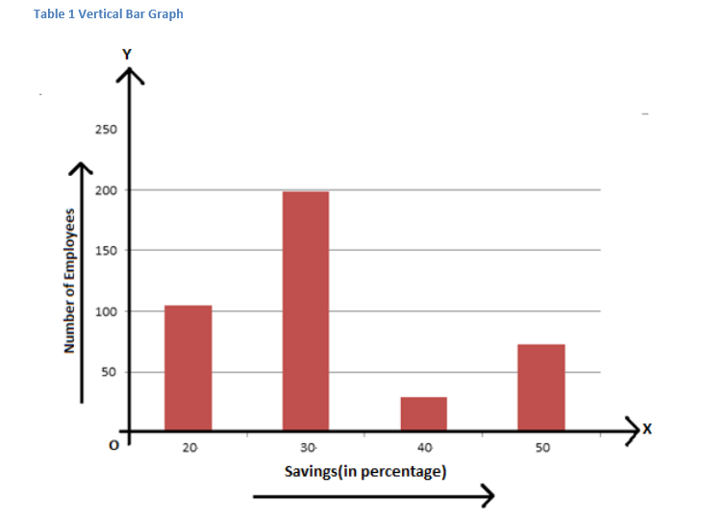
This can be also shown using a horizontal bar graph as follows:
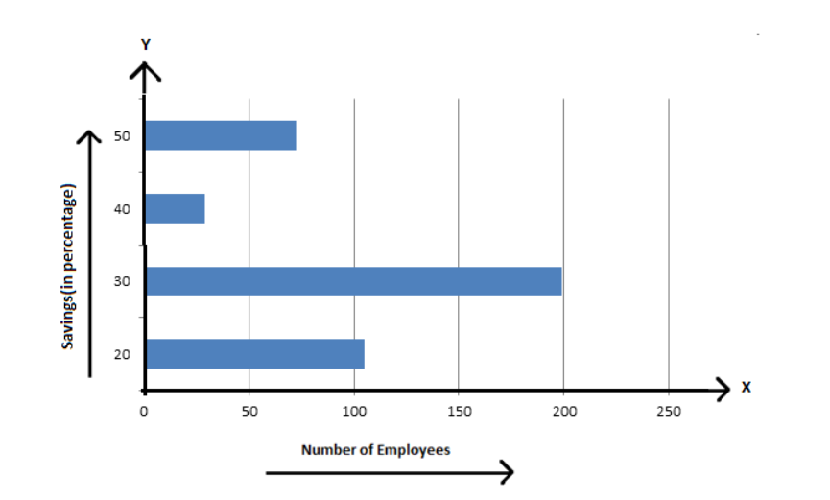
The number of bed-sheets manufactured by a factory during five consecutive weeks is given below
Week | First | Second | Third | Fourth | Fifth
No.o. bed sheets | 600 | 850 | 700 | 900
Draw the bar chart representing the above data.
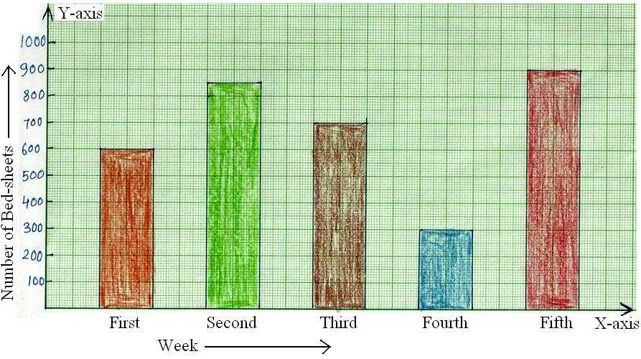
The number of students in 7 different classes is given below. Represent this data on the bar graph.
Class | 6th | 7th | 8th | 9th | 10th | 11th | 12th
Number of students | 130 | 120 | 135 | 130 | 150 | 80 | 75
Represent this data on the bar graph.
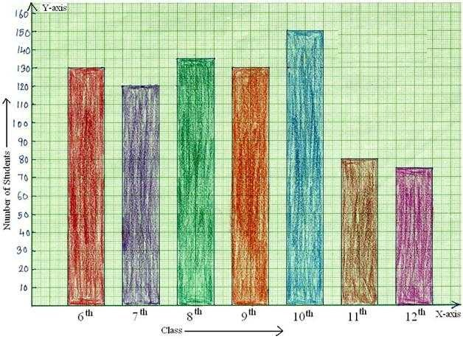
The number of trees planted by Students at Target Secondary School in different years is given below.
Year | 2005 | 2006 | 2007 | 2008 | 2009 | 2010
Number of trees planted | 150 | 220 | 350 | 400 | 300 | 380
Draw the bar graph to represent the data.

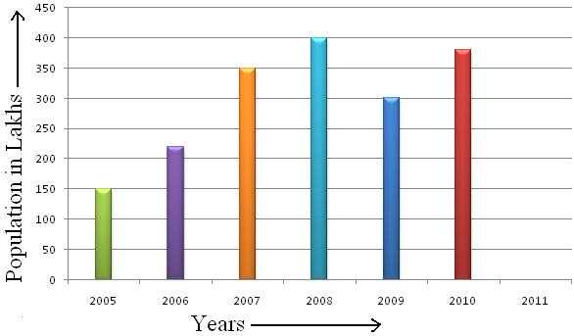
EXERCISE
Imagine your you just did a survey of your friends to find which kind of movie they liked best.
Comedy | Action | Romance | Drama | Scifi
4 | 5 | 6 | 1 | 4
Required
Represent the data on the bar graph.
A table below shows a survey of 145 people asked them.
Fruit | Apple | Orange | Banana | Kiwifruit | Blueberry | Grapes
People | 35 | 30 | 10 | 25 | 40 | 5
Required
Represent the data on the bar graph. Which is the nicest fruit?”
PIE CHART
WORKED EXAMPLE 1
The mean of a sample of 6 numbers is 3.2. An extra value of 3.9 is included in the sample. What is the new mean?
Solution
Total of original numbers = 6 × 3.2
= 19 2 .
New total = 19.2 + 3.9
= 23 1
New mean =23 .1/7
. = 3 .3.
WORKED EXAMPLE 2
The mean number of a set of 5 numbers is 12.7. What extra number must be added to bring the mean up to 13.1?
Solution
Total of the original numbers = 5 × 12.7
= 63 5.
Total of the new numbers = 6 × 13.1
= 78 6.
Difference = 78.6 − 63.5
= 15 1
WORKED EXAMPLE 3
Rohan's mean score in three cricket matches was 55 runs.
  - How many runs did he score altogether?
  - After four matches his mean score was 61 runs.
  - How many runs did he score in the fourth match?
Solution
- Mean = 55 =$\frac{ Total score}{3}$
So total scored = 3 × 55 = 165
- Total scored = 4 × 61 = 244
Fourth match score = 244 − 165
= 79
PIE CHART
A pie chart is a circular statistical graphic which is divided into slices to illustrate numerical proportion. In a pie chart, the arc length of each slice is proportional to the quantity it represents.
CONSTRUCTION OF PIE CHART
A pie chart is a circular graph which is used to represent data. In this:
- Various observations of the data are represented by the sectors of the circle.
- The total angle formed at the centre is${360}^{o}$.
- The whole circle represents the sum of the values of all the components
- The angle at the centre corresponding to the particular observation component is given by
$\frac{Value of the component }{Total value}$ x ${360}^{o}$
- If the values of observation/components are expressed in percentage, then the centre angle corresponding to particular observation/component is given by
$\frac{ Percentage value of component}{100}$ x ${360}^{o}$
HOW TO CONSTRUCT A PIE CHART?
Steps of construction of pie chart for a given data:
- Find the central angle for each component using the formula.
- Draw a circle of any radius
- Draw a horizontal radius
- Starting with the horizontal radius, draw radii, making central angles corresponding to the values of respective components.
- Repeat the process for all the components of the given data.
- These radii divide the whole circle into various sectors.
- Now, shade the sectors with different colours to denote various components.
- Thus, we obtain the required pie chart.
EXAMPLE
    - The following table shows the numbers of hours spent by a child on different events on a working day. Represent the adjoining on a pie chart.
Activity | Number of hours
School | 6
Sleep | 8
Playing | 2
Study | 4
Television | 1
Others | 3
SOLUTION
The central angles for various observations can be calculated as:
Activity | Number of hours | Measure of central angle
School | 6 | $$\left(\frac{6}{24} x {360}^{o}\right)={90}^{o}$$
Sleep | 8 | $$\left(\frac{8}{24} x {360}^{o}\right)={120}^{o}$$
Playing | 2 | $$\left(\frac{2}{24} x {360}^{o}\right)={30}^{o}$$
Study | 4 | $$\left(\frac{4}{24} x {360}^{o}\right)={60}^{o}$$
Television | 1 | $$\left(\frac{1}{24} x {360}^{o}\right)={15}^{o}$$
Others | 3 | $$\left(\frac{3}{24} x {360}^{o}\right)={45}^{o}$$
The pie chart from the above calculations
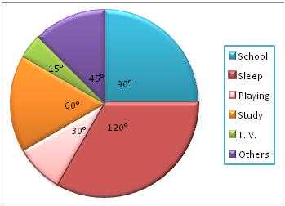
    - The favourite flavours of ice-cream for the children in a locality are given in percentage as follow. Draw the pie chart to represent the given information.
Flavours | % of students prefer the flavours
Vanilla | 25%
Strawberry | 15%
Chocolate | 10%
Kersa- Pista | 30%
Mango Zap | 20%
SOLUTION
Flavours | % of students prefer the flavours | % of students prefer the flavours
Vanilla | 25% | $$\left(\frac{25}{100} x {360}^{o}\right)={90}^{o}$$
Strawberry | 15% | $$\left(\frac{15}{100} x {360}^{o}\right)={54}^{o}$$
Chocolate | 10% | $$\left(\frac{10}{100} x {360}^{o}\right)={36}^{o}$$
Kersa- Pista | 30% | $$\left(\frac{30}{100} x {360}^{o}\right)={108}^{o}$$
Mango Zap | 20% | $$\left(\frac{20}{100} x {360}^{o}\right)={72}^{o}$$
PIE CHART
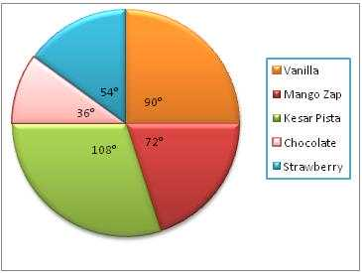
The total area of Asia, Africa, North America, South America, Europe and Australia is 134 million square kilometers. The pie chart below shows the percentages of percentages of each continent.
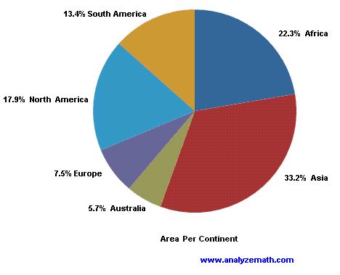
- What is the area of Asia?
- What is the area Europe?
- How much bigger is Africa than Europe?
SOLUTION
- 33.2% x 134 = 44.5 million kilometers
- 7.5% x 134 = 10.5 million square kilometers
- (22.3 -7.5%) X 134 = 19.8 million square kilometer
The pie chart below shows the percentages of the world population in each continent. The present world population is about 7 billion.
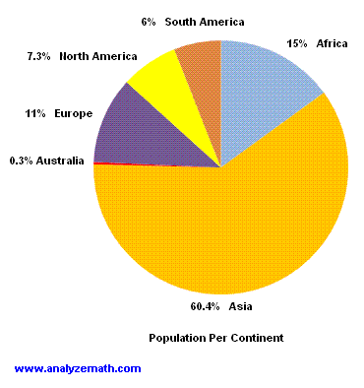
Required
- How many people live in Africa?
- How many people do not live in Asia?
- How many more people live in North America than in South America?
SOLUTION
- 15% x 7 = 1.05 billion
- 7 $-$ 60.4% x 7 = 2.772 billion
- $\left(7.3\%-6\%\right)$ x 7 = 91 million.
The pie chart below shows the percentages of types of transportation used by 800 students to come to school.
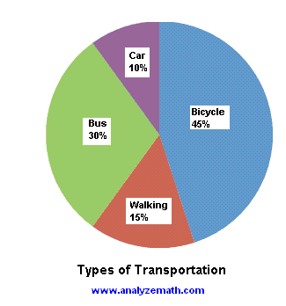
Required
- How many students, in the school, come to school by bicycle?
- How many students do not walk to school?
- How many students come to school by bus or in a car?
SOLUTION
      - 45% X 800 = 360 Students
      - (100% -15%) x 800 = 680 students
      - (30% + 10%) x 800 = 320 students
The pie chart below shows the percentages of blood types for a group of 200 people.
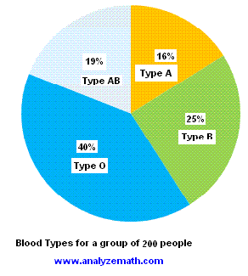
Required
- How many people, in this group, have blood type AB?
- How many people, in this group, do not have blood type O?
- How many people, in this group, have blood types A or B?
SOLUTION
- 19% x 200 = 38 people
- (100% -40%) x 200 = 60% x 200 = 120 people
- (16% +25%) x 200 = 41% x 200 = 82 people
Imagine you survey your friends to find the kind of movie they like best.
Comedy | Action | Romance | Drama | Scifi
4 | 5 | 6 | 1 | 4
Required.
Represent the data by the pie chart.
SOLUTION
Comedy | Action | Romance | Drama | Scifi | Total
4 | 5 | 6 | 1 | 4 | 20
Next divide each value by the total and multiply by ${360}^{o}$ to get a percent.
Comedy | Action | Romance | Drama | Scifi | Total
4 | 5 | 6 | 1 | 4 | 20
$$\left(\frac{4}{20} x {360}^{o}\right)={72}^{o}$$ | $$\left(\frac{5}{20} x {360}^{o}\right)={90}^{o}$$ | $$\left(\frac{6}{20} x {360}^{o}\right)={108}^{o}$$ | $$\left(\frac{1}{20} x {360}^{o}\right)={18}^{o}$$ | $$\left(\frac{4}{20} x {360}^{o}\right)={72}^{o}$$

EXERCISES
The table below shows the number of cars of each colour that passed through Dunduzu Roadblock on Republic Day.
Colour | Number of cars
Blue | 75
Red | 45
Green | 150
White | 300
Black | 30
Required
Represent this information in a pie chart
FREQUENCY POLYGON
A frequency polygon is a graph constructed by using lines to join the midpoints of each interval, or bin. The heights of the points represent the frequencies.
A frequency polygon can be created from the histogram or by calculating the midpoints of the bins from the frequency distribution table.
CONSTRUCTION OF FREQUENCY POLYGON USING HISTOGRAM
Step1
Obtain the frequency distribution from the given data and draw a histogram.
Step 2
Join the mid-points of the tops of adjacent rectangles of the histogram by means of the line segments.
Step 3
Obtain the midpoints of two assumed class intervals of zero frequency, one adjacent to the first bar on its left and another adjacent to the last bar on its right. These class intervals are known as imagined class interval.
Step 4
Complete the polygon by joining the midpoint s of first and last class intervals to the midpoint of the imagined class intervals adjacent to them.
EXAMPLE
Draw a frequency polygon imposed on the histogram for the following distribution.
Class interval | 10-20 | 20-30 | 30-40 | 40-50 | 50-60 | 60-70 | 70-80 | 80-90
Frequency | 4 | 6 | 8 | 10 | 12 | 14 | 7 | 5
SOLUTION
- Mark the class intervals along the x-axis and the frequencies along the Y-axis with appropriate scale shown in the figure given below.
- Draw a histogram for the given data. Now mark the midpoints of the upper sides of the consecutive rectangles.
- Aso we take the imagined class intervals (-10) -0 and 60-70
THE FREQUENCY POLYGON
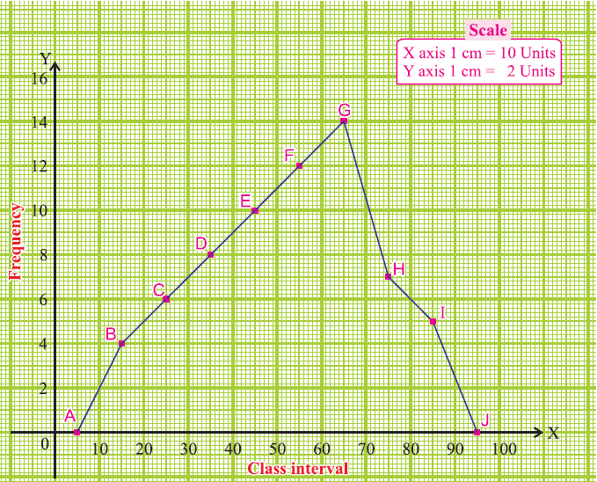
The following frequency polygon displays the weekly incomes of labourers of a factory.
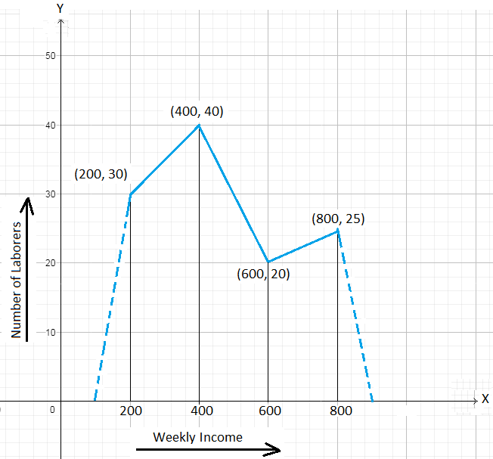
Required
- Find the class interval whose frequency is 25.
- How many labourers have a weekly income of at least K500 but not more than K700?
- What is the range of weekly income of the largest number of labourers?
- Prepare the frequency distribution table.
SOLUTION
- The frequency 25 corresponds to the class mark 800.
The common width of class intervals = 400-200= 200
So, the class interval is $\left(800-\frac{200}{2}\right)$-$\left(800+\frac{200}{2}\right)$, that is 700-900.
- The number of labourers has to fall in the class interval 500-700 whose class mark is 600. The frequency corresponding to the mark 600 is 20. Hence, the required number of labourers is 20.
- The largest number of labourers belongs to the class interval whose mark is 400. The corresponding class interval is $\left(800-\frac{200}{2}\right)$-$\left(800+\frac{200}{2}\right)$, so the largest numbers of labourers have a weekly income of at least K300 but less than K500.
- Frequency table
Weekly income (IN$ | Number of labourers
100-300 | 30
30-500 | 40
500-700 | 20
700-900 | 25

HISTOGRAM
Histogram is a graphical display of data using bars of different heights. It is similar to a bar chart but a histogram groups numbers into ranges. The height of each bar shows how many fall into each range. Histogram shows continuous data. The continuous data takes the form of class intervals.
In other words, histogram is a graphical representation of a frequency distribution with class intervals or attributes as the base and frequency as the height.
A histogram consists of rectangles, each of which has breadth equal or proportional to the size of the concerned call interval, and height equal or proportional to the corresponding frequency.
PARTS OF A HISTOGRAM
    - The title: The title describes the information included in the histogram.
    - X-axis: The X-axis are intervals that show the scale of values which the measurements fall under.
    - Y-axis: The Y-axis shows the number of times that the values occurred.
    - The bars: The height of the bar shows the number of times that the values occurred within the interval, while the width of the bar shows the interval that is covered.
CONSTRUCTION OF A HISTOGRAM
To make a histogram, follow these steps
- On the vertical axis, place frequencies. Label this axis “Frequency”.
- O the horizontal axis, place the lower value of each interval
- Draw a bar extending from the lower value of each interval to the lower value of the next interval,
FREQUENCY HISTOGRAM
A frequency Histogram is a special graph that uses vertical columns to show frequencies (how many times each score occurs).
EXAMPLES
The histogram below shows the heights in com distribution of 30 people.
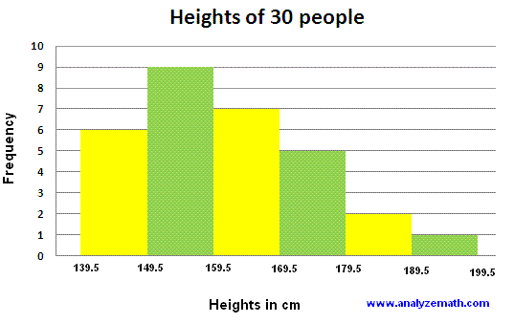
Required
- How many people have heights between 159.5 AND 169.5 cm?
- How many people have heights less than 159.5cm?
- How many people have heights more than 169.5cm?
- What percentage of people has heights between 149.5 and 179.5cm?
SOLUTION
- 7 people
- 9 + 6 =15 people.
- 5+2 + 1 = 8 people
- (9+7+5)/30 =0.7 x100%
=70%
EXAMPLE
The histogram below shows the level of cholesterol in mg per dl of 200 people.
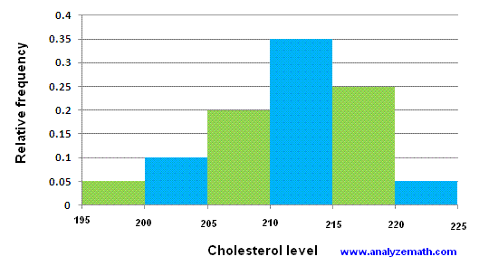
- How many people have a level of cholesterol between 205 and 210 mg per dl?
- How many people have a level of cholesterol less than 205m per dl?
- What percentage of people have cholesterol more than 215mg per dl?
- How many people have a level of cholesterol between 205 and 220mg per dl?
SOLUTION
Note that the relative frequency is shown on the vertical axis
- 0.2 x 200 = 40 people
- (0.05 + 0.1) x 200 = 30 people
- (0.25 + 0.05) =30%
- (0.2 + 0.35 + 0.250 x 200 = 160 people
EXAMPLE
The histogram below shows the efficiency level (in miles per gallons) of 110 cars.
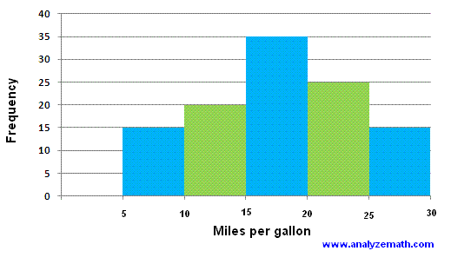
Required
- How many cars have efficiency between 15 and 20 miles?
- How many cars have efficiency more than 20 miles per gallon?
- What percentage of cars has efficiency less than 20 miles?
SOLUTIONS
- 35 cars
- 25 + 15 = 40 cars
- (15 +20 +35)/110 = 0.626x 100%
= 62.6%

